Crime Analysis Dashboard – Design & Specification Documentation

Project | CRU (Crime Response Unit) – Crime Data Visualization
Version | v1.0
Prepared by | Priyanka Lenka (Data Analyst Project)
Date | August 2025
Tool | Microsoft Power BI

1. Project Objective
This document provides a complete specification for the development of the CRU Analytics Dashboard, an interactive Power BI solution designed to help the Crime Response Unit monitor, analyze, and respond to crime cases effectively.

The goal of this project is to replicate how a real-world crime monitoring unit would function by centralizing multiple crime-related datasets into one platform, applying data cleaning and modeling techniques, and building dashboards that support decision-making, performance tracking, and crime prevention strategies.

It outlines the dashboard structure, data behaviour, filters, user interactivity, applied DAX logic, and visualization design used to create the final solution.

2. CRU (Crime Response Unit) Overview

The Crime Response Unit (CRU) is a specialized analytical and monitoring team concept designed to:
- Record crime data systematically (FIRs, victims, accused, chargesheets, disposal).
- Analyze crime trends by geography, type, and time period.
- Respond quickly to emerging issues by identifying hotspots and anomalies.
- Support operational teams by tracking workload, closure rates, and resolution times.
- Improve accountability and transparency in handling crime cases.

CRU acts as the bridge between raw case reporting and actionable insights, helping law enforcement agencies plan better, deploy resources efficiently, and improve case resolution.

3.Target Audience
This dashboard has been designed for police leadership, policy analysts, and senior decision-makers in the Crime Records Unit.
- Police Leadership (SP/DSP/PS in-charge): To monitor performance of police stations, disposal rates, and pending backlog.
- Policy Analysts / Crime Analysts: To study long-term trends (YoY, seasonality, demographic breakdowns) and prepare reports for higher authorities.
- Judicial Oversight Bodies: To review delays in court disposal vs police disposal and identify systemic bottlenecks.
- General Administration: To use hotspot maps and demographic profiles for resource planning and awareness campaigns.

4. Objectives of the Dashboard
The CRU Analytics Dashboard was built with the following objectives:
- Centralize crime data into a single, interactive platform.
- Analyze crime patterns by geography, time, and type of offence.
- Support resource planning and response strategy.
- Improve transparency and accountability by tracking open vs. closed cases.
- Detect crime hotspots, seasonal spikes, and anomalies.
- Measure police unit performance (closure rate, resolution time, pending workload).

5. Data Collection
This dashboard is built on case-level data provided by the Crime Records Unit.
- Time Range:
  - Earliest Record: 31st January 2020 (01:40 AM)
  - Latest Record: 30th January 2025 (11:50 PM)
  - Total Span: ~5 years of data (Feb 2020 – Jan 2025)
  - Complete Years: 2020, 2021, 2022, 2023, 2024
  - Partial Year: 2025 (only data until January 30, 2025). Treated as YTD and excluded from YoY comparisons to avoid misleading trends.
- Geographical Coverage: Data spans across 45 districts and 50 police stations.
- Data Grain: Case-level (each row represents one FIR/case linked with CaseMaster and associated tables).
- Data Volume:
Table Name | Records | Columns | Description
Accused | 237,773 | 15 | Contains demographic and identifying details of accused individuals, including age, gender, caste, and occupation, which enable profiling and trend analysis.
Chargesheet | 54,325 | 6 | Provides information about chargesheets filed, such as chargesheet number, filing date, and linking with case ID, helping to measure timeliness and compliance.
Act Section | 349,029 | 6 | Captures the sections of law under which cases are registered. This helps in classifying crimes into Heinous/Non-Heinous and analyzing crime categories under IPC and Special Acts.
Crime | 211,863 | 18 | Core dataset containing FIR and case-level details such as crime type, location, registration date, and linkage with police station IDs. Serves as the backbone of the analysis.
Disposal | 17,660 | 5 | Stores case disposal information, including disposal type (e.g., Convicted, Acquitted, Pending) and disposal date, which supports efficiency and backlog analysis.
PS Unit | 1,856 | 4 | Master reference table listing all police stations, districts, and geographical coordinates (latitude/longitude) used for spatial mapping and hotspot analysis.
Victim | 141,398 | 15 | Contains demographic details of victims, including age, gender, caste, and occupation. Used to identify vulnerable groups and generate victim demographic profiles.

6. Data Explanation (Data Dictionary)

6.1 Crime Table (Main Case Information)

Record: FIR (First Information Report) details

Field | Description | Use Case
District_Name | District where the crime was reported | Important to see which districts have higher/lower crime.
UnitName | Police station/unit handling the case. | Helps analyze workload across stations.
FIRNo | FIR number (official police case number) | Unique identifier used internally.
Fir_ID | System-generated ID for each FIR. | Used to link with other tables (Victim, Accused, etc.).
Pin_Code | Area postal code | Gives location context for mapping.
Direction_Distance | Location description relative to a landmark | Helps in tracing exact spot if GPS is missing
Beat | Police beat (smaller area under a station) | Used for micro-level hotspot analysis.
Village | Village name
FIR Type | Cognizable / Non-Cognizable offence | Cognizable = police can arrest without warrant (e.g., murder, theft). Non-cognizable = need court approval
FIR_Stage | Stage of FIR (e.g., Registered, Under Investigation, Closed) | Tracks case progress
CrimeGroup_Name | Broad category of crime (Theft, Assault, Cybercrime)
CrimeHead_Name | Specific type (e.g., Vehicle Theft, Chain Snatching)
Latitude & Longitude | Geo coordinates of crime spot. | For mapping & hotspot detection.
Offence_From_Date / To_Date | Period when crime occurred.
FIR_Date | Date FIR was registered | Date FIR was registered.

.
6.2 Victim Table

Record: Stores information about victims

Field | Description | Use Case
Sex | Gender of victim (Male/Female/Other) | Important for gender-based crime studies
Age / DOB | Age & Date of Birth of victim | Used for age-based vulnerability analysis (e.g., crimes against children, elderly)
Height | FIR number (official police case number)
Nationality, Religion, Caste | Background detail | Sociological analysis, but must be anonymized for privacy.
Occupation | Job of victim. | Detects if certain groups (students, workers, professionals) are targeted more
Perm_Pincode / Pres_Pincode | Permanent & present addresses
Injury_Type | Type of injury (e.g., minor, grievous)
Injury_Nature | Nature of harm (e.g., physical, psychological)
VictimType | Individual, Institution, Company etc
FIR_ID, Unit_ID | Links victim to the case

6.3 Accused Table

Record: Information about the accused persons.

Field | Description | Use Case
Arr_ID | Unique ID of accused person in dataset
OffenderType | First-time offender, habitual offender, etc
Sex, Age, DOB | Demographics of accused
Height, Nationality, Occupation, Religion, Caste | Background info
Conviction_Date | If convicted, date of conviction | Useful for conviction rate tracking
Perm_Pincode, Pres_Pincode | Addresses of accused
FIR_ID, Unit_ID | Connects accused to FIR

6.4 ChargeSheet Table

Record: When investigation is complete, police file a chargesheet in court.

Field | Description | Use Case
CaseMasterID | Case identifier | for linking with Dispose table
CASEChargesheetID | Chargesheet unique ID
ChargesheetNo | Official chargesheet number
Fir_id | Connects to main crime case
Unit_id | Police unit handling the case
Chargesheet_Date | Date when chargesheet was filed

6.5 Dispose Table
Record: Represents how and when cases were disposed/closed.
Field | Description | Use Case
CaseMasterID | Unique case identifier | Links disposal records with case master table
CASEChargesheetID | Chargesheet unique ID | Connects disposal record with chargesheet
Fir_id | FIR identifier | Links disposal entry to main case FIR
Unit_id | Police unit ID | Identifies which police unit handled the case
Dispose_Date | Date of case disposal/closure | Used for calculating case resolution and pending duration

6.6 Act Section Table
Record: Details of legal acts/sections applied to cases.
Field | Description | Use Case
Act_Code | Legal Act code (e.g., IPC, IT Act) | Identifies the main Act under which case was filed
Act_Description | Full name of Act | Provides clarity on Act used (e.g., Indian Penal Code)
Section_Code | Section number of Act (e.g., IPC 302) | Specifies exact section invoked (e.g., Murder)
Sec_Description | Section details/definition | Explains scope of legal section
Fir_id | FIR identifier | Connects applied Act/Section to a specific FIR
Unit_id | Police unit ID | Identifies police unit responsible for applying section
.

6.7Ps Unit Table (Police Station Master)

Record: Lookup table for police stations.

Field | Description | Use Case
UnitID | Unique police station identifier | Primary key to link cases with specific police station
UnitName | Name of the police station | For reporting and station-level analysis
Latitude | Latitude coordinate of station | Enables mapping police stations on GIS/Spatial visuals
Longitude | Longitude coordinate of station | Used along with latitude to plot PS locations on map
UnitID | Unique police station identifier | Primary key to link cases with specific police station
UnitName | Name of the police station | For reporting and station-level analysis

7. Power Query Transformation
7.1 Fact_Crime
Step | Description | Action | Reason (Why + How it helps)
1 | Imported dataset from Excel | Import Data | Ensures full raw Fact_Crime dataset is available for transformation
2 | Selected sheet “Crime” | Select Sheet | Focuses only on crime records → avoids loading irrelevant sheets
3 | Promoted first row as headers | Promote Headers | Converts row into usable field names → improves readability
4 | Converted fields into correct data types | Change Data Type | Prevents calculation errors, supports consistent reporting
5 | Created Key column = Fir_id & Unit_ID | Add Custom Column | Ensures unique identifiers → supports accurate joins
6 | Extracted Year from FIR_Date | Extract Function | Enables yearly trends & YOY analysis
7 | Renamed FIR_Date → FIR_Date_Time | Rename Column | Differentiates datetime field from date-only version
8 | Duplicated FIR_Date_Time | Duplicate Column | Backup for transformation into clean date-only
9 | Renamed FIR_Date_Time - Copy → FIR_Date | Rename Column | Restores dedicated date field for analysis
10 | Converted FIR_Date to date-only | Change Data Type | Ensures clean joins with Calendar & trends
11 | Created Case Status column (Active/Closed/Blank) | Conditional Column | Simplifies FIR stages → helps in workload monitoring
12 | Extracted time from Offence_From_Date | Extract Function | Supports time-of-day crime analysis
13 | Converted Offence Time → Time type | Change Data Type | Validates time field → enables grouping
14 | Created Offence Time Period buckets | Conditional Column | Groups crimes by dayparts → helps spot peak hours
15 | Converted text fields to Proper Case | Text Transformation | Removes inconsistencies → avoids duplicates
16 | Duplicated Longitude column | Duplicate Column | Keeps original safe → one copy for mapping
17 | Renamed Latitude/Longitude copies → Lat, Long | Rename Columns | Short names → easier for map visuals
18 | Converted FIR_Date → DateTime | Change Data Type | Supports calculations needing timestamps
19 | Merged Fact_Crime with ChargeSheet table | Merge Query | Adds chargesheet details → links lifecycle data
20 | Extracted Chargesheet_Date | Expand Column | Keeps only necessary column for analysis
21 | Renamed Chargesheet_Date | Rename Column | Standard, intuitive naming
22 | Merged Fact_Crime with Dispose table | Merge Query | Adds disposal information
23 | Extracted Dispose_Date | Expand Column | Keeps only relevant column
24 | Renamed Dispose_Date | Rename Column | Consistency across model
25 | Added column = Chargesheet_Date - FIR_Date | Add Custom Column | Tracks investigation time (FIR → Chargesheet)
26 | Converted investigation time → Whole Number | Change Data Type | Numeric consistency → enables averages
27 | Added column = Dispose_Date - FIR_Date | Add Custom Column | Tracks total case resolution timeline
28 | Converted disposal time (DD - CD) → Whole Number | Change Data Type | Ensures numeric reliability
29 | Added column = Dispose_Date - FIR_Date | Add Custom Column | Alternative KPI for disposal duration
30 | Converted disposal time (DD - FD) → Whole Number | Change Data Type | Provides clean closure KPI
31 | Created Case_status column with 4 groups | Conditional Column | Consolidates multiple FIR stages → supports funnel/lifecycle views
32 | Extracted Hour from Offence Time | Extract Function | Enables hour-level crime analysis
33 | Converted FIRNo → Text | Change Data Type | Preserves FIR formatting (leading zeros)
34 | Removed duplicates on Key (2 rounds) | Remove Duplicates | Ensures one record per FIR → avoids double counting

7.2 Dim_Accused

Step | Description | Action | Reason (Why + How it helps)
1 | Source Import | Connected Power Query to Excel file final_dataset_for_showcase.xlsx and selected Accused sheet | Brings raw accused records into Power BI → starting dataset with demographic & legal details
2 | Select Sheet | Selected Accused sheet from workbook | Loads only relevant sheet → avoids unnecessary tables
3 | Promote Headers | Converted first row to column headers | Provides proper field names (Arr_ID, OffenderType, etc.) → prevents generic names like Column1
4 | Change Data Types | Converted: Arr_ID, Height, Age → Whole Number; DOB, Conviction_Date → Text (initial); OffenderType, Sex, Religion, Occupation, Caste, Nationality, Unit_ID, FIR_ID → Text | Ensures numeric/date/category fields behave correctly → avoids calculation errors in averages, timelines, groupings
5 | Replace NULL in Demographics | Replaced “NULL” with “Unknown” in Sex, Religion, Caste | Standardizes missing values → prevents NULL showing in visuals, keeps category grouping clean
6 | Create Case Key | Added Key = FIR_ID & "-" & Unit_ID | Unique case-level key → ensures consistent joins across tables
7 | Create Age Segment | Conditional Column: If Age=0 → Unknown; ≤12 → Children (0–12); ≤19 → Teenagers (13–19); ≤29 → Youths (20–29); ≤39 → Adults (30–39); ≤59 → Middle-Aged (40–59); Else → Senior Citizen (60+) | Groups raw ages into categories → simplifies demographic analysis
8 | Standardize Text to UPPER | Converted Sex, Religion, Caste → UPPERCASE | Removes variations (male/Male/MALE) → prevents duplicate categories
9 | Format to Proper Case | Converted Sex, Religion, Caste, OffenderType, Occupation → Proper Case | Improves readability → professional-looking labels in visuals
10 | Create Offender Key | Added Key_Offender = FIR_ID & "-" & Unit_ID & "-" & Arr_ID | Guarantees unique identifier per accused → enables headcount analysis
11 | Standardize Sex Codes | Conditional Column: M/m → Male; F/f → Female; T/t → Trans; N/n → Unknown; else → Unknown | Cleans inconsistent codes → supports reliable gender-based crime analysis
12 | Filter Invalid Ages | Filtered rows where Age >= 0 and Age <= 100 | Removes unrealistic ages → ensures trustworthiness in averages & demographics
13 | Replace NULL in Occupation | Replaced “Null” with “Unknown” in Occupation | Consistent handling of missing values → prevents fragmented categories
14 | Convert Conviction Date | Changed Conviction_Date from Text → DateTime | Enables timeline calculations → supports KPIs like time-to-conviction

7.3 Dim_act_section
Step | Description | Action | Reason (Why + How it helps)
1 | Source Import | Imported Crime sheet from Excel file | Provides base case-level dataset
2 | Promote Headers | Converted first row to column headers | Standardizes structure → prevents Column1, Column2 issues
3 | Change Data Types | FIR ID, Unit ID → Text; Dates → DateTime; numeric fields → Whole Number | Ensures accuracy in joins & calculations
4 | Create Case Key | Added Key = FIR_ID & "-" & Unit_ID | Unique identifier per case → enables joins with Dispose & Chargesheet

7.4 Dim_ chargesheet
Step | Description | Action | Reason (Why + How it helps)
1 | Source Import | Imported Chargesheet sheet from Excel file | Provides chargesheet-level data for FIR tracking
2 | Select Sheet | Selected Crime sheet from workbook | Avoids unnecessary sheets, loads only relevant data
3 | Promote Headers | Converted first row to headers | Standardizes structure → clean field names
4 | Change Data Types | IDs → Int64; FIR & Unit → Text; Date → DateTime | Ensures correct formats → avoids type errors in joins
5 | Create Case Key | Added Key = Fir_id & "-" & Unit_id | Uniquely identifies FIR across units → reliable joins
6 | Group & Aggregate | Grouped by Key → took List.Max(Chargesheet_Date) | A case can have multiple chargesheets → ensures analysis uses latest date

7.5 Dim_Disposed

Step | Description | Action | Reason (Why + How it helps)
1 | Source Import | Imported Dispose sheet from Excel file | Provides case disposal information → enables tracking of FIR outcomes
2 | Select Sheet | Selected Crime sheet from workbook | Avoids unnecessary sheets, loads only relevant data
3 | Promote Headers | Converted first row to headers | Standardizes structure → provides clean column names
4 | Create Case Key | Added Key = Fir_id & "-" & Unit_id | Ensures unique FIR across units → supports joining with fact_crime
5 | Change Data Type (Dispose Date) | Converted Dispose_Date → DateTime (en-IN locale) | Standardizes dates → enables time-based analysis
6 | Change Data Types (IDs) | Converted IDs (CaseMasterID, CASEChargesheetID) → Int64; FIR & Unit → Text | Ensures consistency in joins & calculations
7 | Remove Duplicates | Kept distinct rows on CaseMasterID | Removes repeated entries → prevents double-counting disposed cases

7.6 dim_ps_lat_long

Step | Description | Action | Reason (Why + How it helps)
1 | Source Import | Imported Ps Unit sheet from Excel file | Extracts police station details with latitude & longitude → adds geospatial dimension
2 | Select Sheet | Selected Crime sheet from workbook | Loads only relevant data → avoids unnecessary sheets/tables
3 | Promote Headers | Converted first row to headers | Standardizes structure → provides clean field names for joins
4 | Change Column Types | Converted UnitID → Int64; UnitName → Text; Latitude & Longitude → Decimal Numbers | Ensures correct formats → enables mapping and numeric operations
5 | Standardize Text | Converted all UnitName values to UPPERCASE | Removes variations in casing → prevents mismatches during joins
6 | Remove Duplicates | Removed duplicates based on UnitName | Maintains one unique police station per coordinate → ensures accurate mapping

7.7 Dim_Victim
Step | Description | Action | Reason (Why + How it helps)
1 | Source Import | Imported Victim sheet from final_dataset_for_showcase.xlsx | Extracts victim-related details → builds victim dimension linked to FIRs
2 | Select Sheet | Selected Victim sheet from workbook | Ensures only relevant raw data is loaded → avoids unnecessary sheets/tables
3 | Promote Headers | Promoted first row to headers | Standardizes structure → provides proper column names for transformations
4 | Change Column Types | Converted fields: Sex → Text; Age, Height → Int64; DOB → Date; FIR_ID & Unit_ID → Text; others to Text | Correct formats ensure: numeric (Age, Height) usable in calcs; DOB for time analysis; text fields for grouping
5 | Remove Unnecessary Columns | Dropped DOB & Perm_Pincode | Reduces noise → keeps table focused on essential fields
6 | Replace Nulls | Replaced NULL with “Unknown” in Sex, Occupation, Religion, Caste, Injury_type | Standardizes missing data → avoids broken aggregations and ensures categorization
7 | Remove Columns (Injury) | Removed Injury_type & Injury_Nature | Simplifies dimension → keeps focus on demographics and victim type
8 | Create Key Column | Added Key = FIR_ID & "-" & Unit_ID | Ensures uniqueness across units → supports joins with fact_crime and timeline analysis
9 | Create Age Segmentation | Added Age Segment categories (Children, Teenagers, Youths, Adults, Middle-Aged, Senior Citizen, Unknown) | Groups victims into brackets → enables demographic profiling & comparative analysis
10 | Standardize Text | Applied Text.Upper / Text.Proper across Caste, Occupation, Religion, Sex, VictimType | Handles inconsistent casing → prevents duplicates and ensures clean categories
11 | Rename Column | Renamed Sex → Sex_v1 | Keeps original field before recoding → avoids overwriting raw values
12 | Recode Sex | Created standardized Sex column (Male/Female/Trans/Unknown) | Cleans inconsistent entries → enables accurate gender-based victim analysis
13 | Filter Age Range | Kept rows where Age ∈ [0,100] | Removes outliers → ensures demographic analysis is realistic

7.8 Victim Age Segment Order Table

Step | Description | Action | Reason (Why + How it helps)
1 | Source Import (Manual Table) | Created custom table with victim age groups: Children (0–12), Teenagers (13–19), Youths (20–29), Adults (30–39), Middle-aged (40–59), Senior Citizen (60+), Unknown | Defines clear demographic brackets → ensures victims are grouped logically
2 | Add Index Column | Added sequential index values (1–7) | Provides ordering mechanism for categories
3 | Rename Index Column | Renamed Index → Order | Order column ensures custom sort sequence is preserved
4 | Custom Sorting | Used Order column for sorting age groups | Displays age progression naturally (Child → Teenager → Youth → Adult → Middle-aged → Senior) instead of alphabetical order → supports clearer demographic trend analysis

7.9 Victim Sex Order Table

Step | Description | Action | Reason (Why + How it helps)
1 | Source Import (Manual Table) | Created custom table with Victim Gender categories: Male, Female, Trans, Unknown | Defines clear categories for gender dimension
2 | Add Index Column | Added sequential index values (1–4) | Provides ordering mechanism for categories
3 | Rename Index Column | Renamed Index → Order | Order column enables consistent sorting
4 | Custom Sorting | Applied Order column for gender categories | Ensures visuals display genders in logical sequence (Male → Female → Trans → Unknown), rather than alphabetical → improves readability in charts, slicers, and demographic trends

7.10 Offender Sex Order Table

Step | Description | Action | Reason
1 | Source Import (Manual Table) | Created custom table with Offender Gender categories: Male, Female, Trans, Unknown | Defines consistent offender gender categories
2 | Add Index Column | Assigned sequential index values (1–4) | Creates logical ordering mechanism
3 | Rename Index Column | Renamed Index → Order | Prepares column for use in custom sort
4 | Custom Sorting | Applied Order column for offender gender categories | Maintains sort consistency with victim gender → allows side-by-side comparison of victim vs offender gender distribution in visuals

7.11 Offender Age Segment Order Table

Step | Description | Action | Reason
1 | Source Import (Manual Table) | Created custom table with Offender Age Segments: Children (0–12), Teenagers (13–19), Youths (20–29), Adults (30–39), Middle-aged (40–59), Senior Citizen (60+), Unknown | Establishes clear offender age categories
2 | Add Index Column | Assigned sequential numbers (1–7) | Creates a natural chronological order
3 | Rename Index Column | Renamed Index → Order | Prepares field for custom sorting
4 | Custom Sorting | Applied Order column for offender age categories | Ensures offender age groups appear in chronological order, making crime pattern analysis by age group accurate and meaningful

7.12 Time Order Table

Step | Description | Action | Reason
1 | Source Import (Manual Table) | Created custom table with Time Segments: Midnight–6 AM, 6 AM–12 PM, 12 PM–6 PM, 6 PM–Midnight | Defines logical daily time buckets for crime trend analysis
2 | Add Index Column | Assigned sequential numbers (1–4) | Establishes natural progression of time
3 | Rename Index Column | Renamed Index → Order | Used for custom sort order
4 | Custom Sorting | Applied Order column to time segments | Ensures time slots are arranged chronologically instead of alphabetically
5 | Analysis Impact | Enables crime distribution analysis by time of day (e.g., morning vs night) | Helps identify high-risk time periods for preventive actions

7.13 Calendar Table

Code Used:

Calender =
VAR startdate = DATE(YEAR(MIN(Fact_Crime[FIR_Date_Time])),01,01)
VAR Enddate = DATE(YEAR(MAX(Fact_Crime[FIR_Date_Time])),12,31)
RETURN
ADDCOLUMNS(
CALENDAR(startdate,Enddate),
"year",YEAR([Date]),
"month",MONTH([Date]),
"month name",FORMAT([Date],"mmm"),
"day",FORMAT([Date],"dddd"),
"day num",WEEKDAY([Date],1),
"quater",QUARTER([Date]),
"year month",FORMAT([Date],"YYYY-MM"),
"week",WEEKNUM([Date],2),
"halfyearstart",FORMAT([Date],"MM yyyy"),
"halfyearsort",YEAR([Date])*100+MONTH([Date]))

Step | Description | Action | Reason
1 | Define Date Range | Used MIN(Fact_Crime[FIR_Date_Time]) as start date and MAX(Fact_Crime[FIR_Date_Time]) as end date | Ensures calendar covers all available crime data period
2 | Generate Calendar | Created a continuous date range with CALENDAR(startdate, enddate) | Provides a dedicated date dimension required for time intelligence
3 | Add Year & Month | Added Year, Month, and Month Name columns | Enables month/year-based aggregation and ensures chronological sorting
4 | Add Quarter & Half-Year | Created Quarter, HalfYearStart, HalfYearSort | Allows grouping by larger time buckets for trend analysis
5 | Add Week & Day | Created WeekNum, Day, Day Num | Enables weekly trends and weekday/weekend analysis
6 | Add Composite Keys | Created Year-Month and sort columns | Supports proper ordering of visuals (e.g., Jan → Feb → Mar, not alphabetical)
7 | Use in Model | Connected Calendar with FIR_Date, Chargesheet_Date, and Dispose_Date in fact table | Standardizes multiple date fields into one dimension for consistent analysis
8 | Analysis Impact | Used Calendar table in DAX (YoY, MoM, YTD, time differences) | Enables full time-series analysis: trends, seasonality, average processing times

8.Relationships in Your Data Model

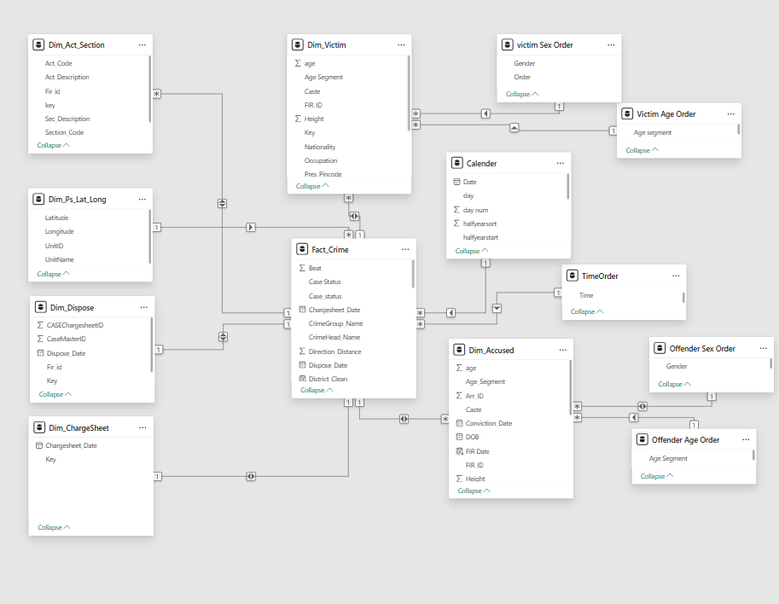

- Dim_Accused (Key) → Fact_Crime (Key)
  - Cardinality: Many-to-One (*:1)
  - Cross Filter Direction: Both
  - Purpose : To analyze crimes based on offender demographics.
  - Why This Choice: A single crime (FIR) can have multiple accused, but each accused must belong to one FIR → so Many accused → One crime. Both filter is chosen so we can slice either from accused to crime or crime to accused.
- Dim_Victim (Key) → Fact_Crime (Key)
  - Cardinality: Many-to-One (*:1)
  - Cross Filter Direction: Both
  - Purpose: To analyze crimes based on victim demographics
  - Why This Choice: A single crime can have many victims, but each victim belongs to one crime. Both filter allows victim-level and FIR-level analysis.
- Dim_Act_Section (Key) → Fact_Crime (Key)
  - Cardinality: Many-to-One (*:1)
  - Cross Filter Direction: Both
  - Purpose: To analyze crimes by law sections.
  - Why This Choice: One crime may involve multiple sections, but one section entry links to only one crime. Both filter allows analysis by law → crime and crime → law.
- Dim_ChargeSheet (Key) → Fact_Crime (Key)
  - Cardinality: One-to-One (1:1)
  - Cross Filter Direction: Both
  - Purpose: To track case progression.
  - Why This Choice: One crime = one chargesheet. If there were multiple chargesheets per crime, it would be 1: but here it's 1:1. Both filter so you can filter from either side.
- Dim_Dispose (Key) → Fact_Crime (Key)
  - Cardinality: One-to-One (1:1)
  - Cross Filter Direction: Both
  - Purpose: To check final case status.
  - Why This Choice: Each case has only one disposal status. That’s why 1:1. Both makes it easy to filter either by disposal status or crime.
- Dim_Ps_Lat_Long (UnitName) → Fact_Crime (UnitName)
  - Cardinality: Many-to-One (*:1)
  - Cross Filter Direction: Both
  - Purpose: To map crimes to police stations
  - Why This Choice: A police station handles many crimes, but each crime belongs to one police station → Many-to-One. Both allows slicing from station → crime and vice versa.
- Calendar (Date) → Fact_Crime (FIR_Date)
  - Cardinality: Many-to-One (*:1)
  - Cross Filter Direction: Single
  - Purpose: To support time intelligence.
  - Why This Choice: Many crimes can happen on one date, but one crime can only happen on one date → Many-to-One. Filter direction kept Single to avoid circular filtering with other date fields.
- TimeOrder (Time) → Fact_Crime (Offence Time Period)
  - Cardinality: Many-to-One (*:1)
  - Cross Filter Direction: Single
  - Purpose: To analyze by time of occurrence.
  - Why This Choice: Many crimes can occur in the same time slot, but one crime has only one time. Single filter avoids loops in the model.

- Victim Age Order (Age Segment) → Dim_Victim (Age Segment)
  - Cardinality: Many-to-One (*:1)
  - Cross Filter Direction: Both
  - Purpose: To group victims by age ranges.
  - Why This Choice: Many victims fall in the same age segment, but one victim has only one age segment. Both filter makes it flexible.
- Victim Sex Order (Gender) → Dim_Victim (Sex)
- Cardinality: Many-to-One (*:1)
- Cross Filter Direction: Both
- Purpose: To group victims by gender.
- Why This Choice: Many victims can be Male/Female/Other, but each victim has only one gender. Both is used for easy drill-down.
- Offender Age Order (Age Segment) → Dim_Accused (Age Segment)
- Cardinality: Many-to-One (*:1)
- Cross Filter Direction: Both
  - Purpose: To group accused by age ranges.
  - Why This Choice: Many accused belong to one age segment. Both filter lets us go either way.
- Offender Sex Order (Gender) → Dim_Accused (Sex)
- Cardinality: Many-to-One (*:1)
- Cross Filter Direction: Both
  - Purpose: To group accused by gender.
  - Why This Choice: Many accused can share the same gender, but each accused has only one gender. Both filter is used for flexibility.

9.Measures

9.1Reporting & Assign

Measure Name | DAX Formula | Purpose | Logic
Reported Cases | = DISTINCTCOUNT(Fact_Crime[key]) | Count all FIRs | Counts distinct case IDs from Fact_Crime.
False Case (B) | =  VAR false_cases = CALCULATE(DISTINCTCOUNT(Fact_Crime[Key]) ,Fact_Crime[FIR_Stage] = "Not Investigated / False Case"  )  RETURN  false_cases | Identify false cases | Filters FIR_Stage and counts false cases.
Transferred Case | =  VAR transferred_cases = CALCULATE(DISTINCTCOUNT(Fact_Crime[Key]),Fact_Crime[FIR_Stage] = "Transferred")  RETURN  transferred_cases | Identify transferred cases | Counts cases marked as “Transferred”.
Assigned Cases | =  ([Reported Cases]-[false case (B)]-[transferred Case]) | Valid FIRs | Removes false & transferred from reported.
Assigned Cases Last Year | =  CALCULATE([Assigned Cases] ,SAMEPERIODLASTYEAR(Calender[Date]))+0 | Compare YOY | Shifts context back 1 year for assigned cases.
Assigned Cases Variance | =  VAR __YearSelected = COUNTROWS(VALUES(Calender[year]))  VAR __BASELINE_VALUE = [Assigned Cases Last Year]  VAR __VALUE_TO_COMPARE = [Assigned Cases]  RETURN  IF(__BASELINE_VALUE=0 || ISBLANK(__BASELINE_VALUE) || __YearSelected>1 ,  "N/A",  DIVIDE(__VALUE_TO_COMPARE - __BASELINE_VALUE, __BASELINE_VALUE)  ) |  | ISBLANK(__BASELINE_VALUE)
Assigned Cases Percentage | =  VAR TotalCasesAssigned = [Assigned Cases]  VAR TotalCasesConstant = [Total Cases (Constant)]  VAR unitperc = DIVIDE(TotalCasesAssigned, TotalCasesConstant, 0)  RETURN unitperc | % Assigned cases | Compares assigned cases to constant baseline.

9.2Pending

Measure Name | DAX Formula | Purpose | Logic
Pending Cases (PS) | =  VAR active_cases_ps = CALCULATE(DISTINCTCOUNT(Fact_Crime[Key]),Fact_Crime[Case_status] = "Pending@PS")  RETURN  active_cases_ps | Pending at PS | Filters Case_status = Pending@PS.
Pending Cases (Court) | =  VAR active_case_court = CALCULATE(DISTINCTCOUNT(Fact_Crime[key]),Fact_Crime[Case_status] = "Pending@Court")  RETURN  active_case_court | Pending at Court | Filters Case_status = Pending@Court.
Pending Cases | =  ([Pending Cases (Court)]+[Pending Cases (PS)]) | Total pending | Adds PS + Court pending.
Pending Cases (%) | =  DIVIDE([Pending Cases] , [Reported Cases],0) | Backlog % | Pending ÷ Reported.
Pending Cases Last Year | =  CALCULATE([Pending Cases],SAMEPERIODLASTYEAR(Calender[Date]))+0 | Compare YOY | Shifts context back 1 year.
Pending Cases YOY % | =  VAR CurrentYear_YTD =CALCULATE (  TOTALYTD ( [Pending Cases], Calender[Date] ))  VAR PreviousYear_YTD =CALCULATE (  TOTALYTD ( [Pending Cases], Calender[Date]),DATEADD ( Calender[Date], -1, YEAR )  )  RETURN  DIVIDE ( CurrentYear_YTD - PreviousYear_YTD, PreviousYear_YTD ) | YOY change | Year-over-year % change for pending.
Pending Cases Variance Colour | =  IF (ISBLANK (  [Reported cases variance] ),  "#FFFFFF", -- White  IF (  [Reported cases variance] > 0, "#FF0000", -- Red  "#008000" -- Green  )) | Visual aid | Returns Red/Green/White based on variance.

9.3Disposed

Measure Name | DAX Formula | Purpose | Logic
Disposed Cases (PS) | =  CALCULATE(DISTINCTCOUNT(Fact_Crime[Key]),Fact_Crime[Case_status] = "Disposed@PS") | Disposed at PS | Filters Case_status.
Disposed Cases (Court) | =  CALCULATE(DISTINCTCOUNT(Fact_Crime[Key]),Fact_Crime[Case_status] = "Disposed@Court") | Disposed at Court | Filters Case_status.
Cases Disposed | =  [disposed cases(Court)]+[disposed cases(PS)] | Total disposed | Adds court + PS disposed.
Disposed Rate | =  DIVIDE([Cases disposed],[Reported Cases],0) | Clearance rate | % disposed out of reported.
Disposed Rate (Court) | =  DIVIDE ([disposed cases(Court)],[Reported Cases],0) | Court disposal rate | Proportion disposed in court.
Disposed Rate (PS) | =  DIVIDE ([disposedcases(PS)],  [ReportedCases],0) | PS disposal rate | Proportion disposed in PS.
Disposal Cases YOY % | =  VAR CurrentYear_YTD =CALCULATE (  TOTALYTD ( [Cases disposed], Calender[Date] ))  VAR PreviousYear_YTD =CALCULATE (  TOTALYTD ( [Cases disposed], Calender[Date]),DATEADD ( Calender[Date], -1, YEAR ))  RETURN  DIVIDE ( CurrentYear_YTD - PreviousYear_YTD, PreviousYear_YTD ) | YOY change | Year-over-year % change in disposals.

9.4Chargesheet

Measure Name | DAX Formula | Purpose | Logic
Cases Chargesheeted (A) | =  VAR tcc = CALCULATE(DISTINCTCOUNT(Fact_Crime[Key]), ISBLANK(Fact_Crime[Chargesheet_Date])= FALSE)  RETURN  (tcc)+0 | Count chargesheeted | Counts cases with Chargesheet_Date.
Cases Chargesheeted ≤60 Days | =  VAR tcc =  CALCULATE(DISTINCTCOUNT(Fact_Crime[Key]),ISBLANK(Fact_Crime[Chargesheet_Date]) = FALSE,  Fact_Crime[Time Diff (CD - FD) ]<=60)  RETURN  (tcc)+0 | Timely chargesheet | Cases completed within 60 days.
Chargesheet Rate v1 | =  ([Cases Chargesheeted(A)] / [Reported Cases]) | Chargesheet rate | Out of reported cases.
Chargesheet Rate ≤60 Days (%) | =  DIVIDE([cases Chargesheeted Within 60days],[Cases Chargesheeted(A)],0) | Timely rate | % of chargesheeted cases filed within 60 days.

9.5Time Metrics
Measure Name | DAX Formula | Purpose | Logic
Average Chargesheet Time | =  AVERAGE(Fact_Crime[Time Diff (CD - FD) ]) | Avg duration | Avg days to file chargesheet.
Average Disposible Time | =  AVERAGE(Fact_Crime[Time Diff(DD-FD)]) | Avg duration | Avg days to dispose.
Average Pending Time (PS) | =  AVERAGE(Fact_Crime[Pending Time (PS)]) | Pending PS | Avg days cases stuck at PS.
Average Pending Time (Court) | =  AVERAGE(Fact_Crime[Pending Time (Court)]) | Pending Court | Avg days cases stuck at Court.
Average Pending Time | =  VAR ps = [average pending time (PS)]  VAR court = [averge pending time (court)]  VAR tpt = ps+court  RETURN  tpt+0 | Combined | Adds both PS + Court pending.

9.6YOY, Icons & Colours
Measure Name | DAX Formula | Purpose | Logic
Reported Cases Variance | =  VAR CurrentYear_YTD =  CALCULATE (  TOTALYTD ( [Reported Cases], Calender[Date] )  )  VAR PreviousYear_YTD =  CALCULATE (  TOTALYTD ( [Reported Cases], Calender[Date]),  DATEADD ( Calender[Date], -1, YEAR )  )  RETURN  DIVIDE ( CurrentYear_YTD - PreviousYear_YTD, PreviousYear_YTD ) | YOY change | Year-over-year % change in reported.
Reported Cases Icon | =  VAR PositiveIcon = "🡅"  VAR NegativeIcon = "🡇"  VAR Nochange = "–"  VAR __YearSelected = COUNTROWS(VALUES(Calender[year]))  VAR __BASELINE_VALUE =  CALCULATE(  TOTALYTD([Reported Cases], Calender[Date]),  DATEADD(Calender[Date], -1, YEAR)  )  VAR __VALUE_TO_COMPARE = [Reported Cases]  VAR yoy =  DIVIDE(__VALUE_TO_COMPARE - __BASELINE_VALUE, __BASELINE_VALUE)  VAR Result =  SWITCH(  TRUE(),  __BASELINE_VALUE = BLANK() && __VALUE_TO_COMPARE > 0, Nochange,  __BASELINE_VALUE = BLANK() && __VALUE_TO_COMPARE = BLANK(), Nochange,  __YearSelected > 1, Nochange,  yoy > 0, PositiveIcon,  yoy < 0, NegativeIcon,  Nochange  )  RETURN Result | Visual trend | Returns arrow icons based on YOY.
Assigned Cases Icon | =  var PositiveIcon = "🡅"  var NegativeIcon = "🡇"  var Nochange = "–"  VAR __YearSelected = COUNTROWS(VALUES(Calender[year]))  VAR __BASELINE_VALUE = [Assigned Cases Last Year]  VAR __VALUE_TO_COMPARE = [Assigned Cases]  VAR yoy = DIVIDE(__VALUE_TO_COMPARE - __BASELINE_VALUE, __BASELINE_VALUE)  var Result =  SWITCH(  TRUE(),  __BASELINE_VALUE = BLANK() && __VALUE_TO_COMPARE > 0 ,Nochange,  __BASELINE_VALUE = BLANK() && __VALUE_TO_COMPARE = BLANK(), Nochange,  __YearSelected>1, Nochange,  yoy > 0, PositiveIcon,  yoy < 0, NegativeIcon,  Nochange  )  RETURN Result | Visual trend | Returns arrow icons based on YOY.
Total Cases Variance Colour | =  IF (  ISBLANK ( [Reported cases variance] ),  "#FFFFFF", -- White  IF (  [Reported cases variance] > 0,  "#FF0000", -- Red  "#008000" -- Green  )  ) | Visual formatting | Red/Green/White colours.
Total Cases (Court) | =  VAR totalcases_court = [Pending Cases (Court)] + [disposed cases(Court)]  RETURN (totalcases_court)+0 | Visual formatting | Colours for assigned variance.
Total Cases (PS) | =  VAR totalcases_court = [Pending Cases (PS)] + [disposed cases(PS)]  RETURN (totalcases_court)+0 | Court load | Total = pending + disposed.
Total Cases (Constant) | =  CALCULATE([Assigned Cases], ALL()) | PS load | Total = pending + disposed.

10. Dashboard

10.1 CRU Crime Analytics-Overall View

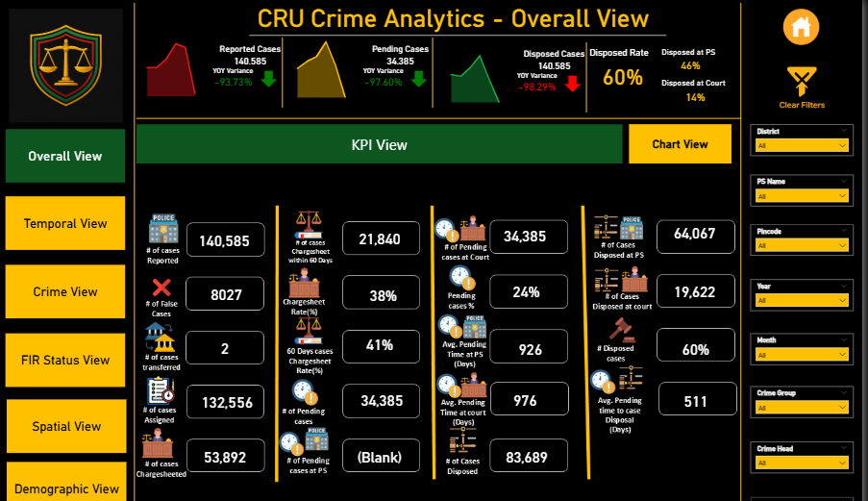

10.1.1 Reporting & Assignment KPIs
KPI Name | Measure(s) Used | Purpose | Insight | Problems / Limitations
# of Cases Reported | [Reported Cases], [Reported Cases Variance] | Show total FIRs & YoY change | Reported cases declined sharply (-93.7% YoY). | Drop suggests data quality/coverage issue.
# of False Cases | [False Case (B)] | Track false or non-investigated cases | False cases reduced (-85.6% YoY). | Year-on-year tagging may be inconsistent.
# of Cases Transferred | [Transferred Case] | Count transferred cases | Transfers nearly disappeared (-99.5% YoY). | Needs verification at district level.
# of Cases Assigned | [Assigned Cases] | Show valid FIRs after exclusions | Case assignments dropped with reported cases. | Assignment criteria may have changed.

10.1.2 Chargesheet & Investigation KPIs
KPI Name | Measure(s) Used | Purpose | Insight | Problems / Limitations
# of Cases Chargesheeted | [Cases Chargesheeted (A)] | Count cases moved to chargesheet stage | Fewer cases moved to chargesheet stage. | Risk of backlog if inflow > disposal.
# of Cases Chargesheeted ≤60 Days | [Cases Chargesheeted Within 60days] | Track timeliness of filing | Timely chargesheeting reduced sharply (-88% YoY). | Identify PS with delays >60 days.
Chargesheet Rate (%) | [Chargesheet Rate v1] | Share of reported cases → chargesheet | Chargesheet rate down to 38%. | Efficiency slipping; compare vs benchmarks.
60-Day Chargesheet Rate (%) | [Chargesheet Rate within 60days (%)] | Proportion chargesheeted ≤60 days | Timely rate dropped to 41%. | Needs breakdown by crime type.

10.1.3 Pending Cases & Delay KPIs
KPI Name | Measure(s) Used | Purpose | Insight | Problems / Limitations
# of Pending Cases | [Pending Cases], [Pending Cases YOY %] | Total backlog cases | Pending backlog reduced sharply (-91% YoY). | May reflect reclassification or data issue.
Pending Cases at Court | [Pending Cases (Court)] | Court backlog | Court pendency reduced to 34K. | Drop unusually steep — validate with court records.
Pending Cases at PS | [Pending Cases (PS)] | PS backlog | PS pendency reduced to 22K. | Possible incomplete PS updates.
Pending Cases % | [Pending Cases (%)] | % of cases pending | Pendency share fell to 40%. | Check denominator consistency.

10.1.4 Disposal KPIs
KPI Name | Measure(s) Used | Purpose | Insight | Problems / Limitations
# of Cases Disposed | [Cases Disposed], [Disposal Cases YOY %] | Total disposals | Steep decline in disposals (-98% YoY). | Indicates systemic slowdown.
Cases Disposed at PS | [Disposed Cases (PS)] | Disposals at PS | PS disposals dropped to 64K (-96%). | Negative efficiency trend.
Cases Disposed at Court | [Disposed Cases (Court)] | Disposals at Court | Court disposals dropped to 19K. | Must check per-district court workloads.
Disposed Rate (%) | [Disposed Rate] | Clearance % of reported cases | Disposal rate fell to 60%. | Efficiency reduced.
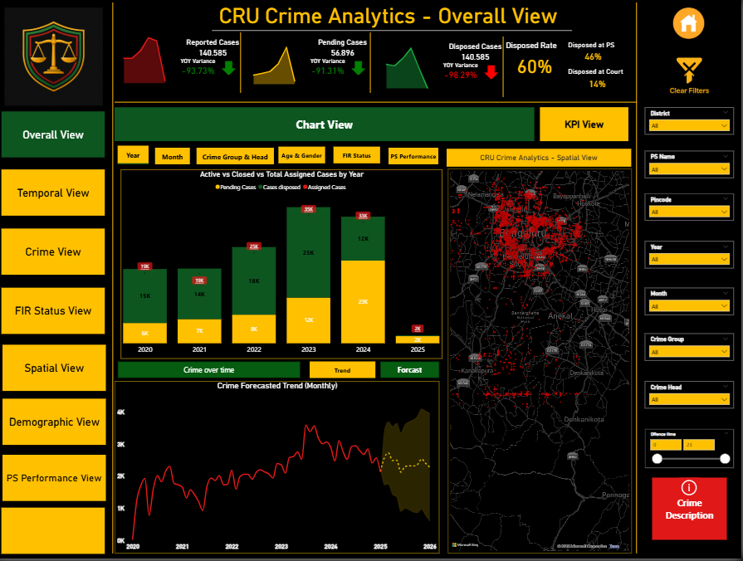

Button | Bookmark Triggered | Visuals Shown | Visuals Hidden | Notes
Month Trends | MonthTrend_BM | Crimes by Month (clustered bar chart) | Year Trends, Crime Group Trends, Age & Gender Slicer, FIR Status Chart, PS Performance, Forecast, Trends | Shows seasonal variation
Year Trends | YearTrend_BM | Crimes by Year (line/column chart) | Others | Highlights yearly growth/decline
Crime Group Trends | CrimeGroupTrend_BM | Heinous vs Non-Heinous Crimes (bar chart) | Others | Connects with Crime View page
Age & Gender Slicer | AgeGender_BM | Victim demographics (Age, Gender) | Others | Demographic filter applied
FIR Status Chart | FIRStatus_BM | Pending vs Disposed FIRs (bar chart) | Others | Quick FIR snapshot
PS Performance | PSPerf_BM | Pending vs Disposed by Police Station | Others | Shortcut to PS page
Forecast | Forecast_BM | Crime Forecast 2026 | Others | Based on 2020–2024, excludes 2025
Trends | Trends_BM | General crime trend line (default view) | All other variations | Default state when page loads

Overall View – Crime Cases Analysis

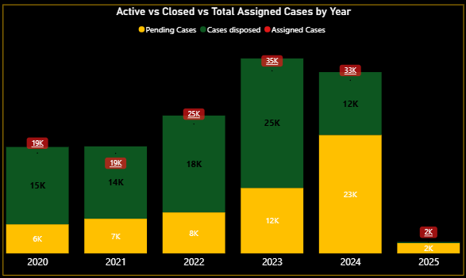
Active vs Closed vs Total Assigned by Year
Aspect | Details
Visual Type | Line & Stacked Column Chart
Data Fields | X-Axis: Year  Column Y-Axis: Pending Cases, Cases Disposed  Line Y-Axis: Assigned Cases
Measure(s) Used | [Assigned Cases], [Pending Cases], [Cases Disposed]
Purpose | Show year-wise lifecycle trend of Assigned, Pending, and Disposed cases.
Insights | - Assigned cases peaked in 2023 (35K) before falling in 2024–2025.  - Pending cases also high in 2023, backlog accumulation.  - Sharp decline in 2025 (only 2K cases), possible data entry cutoff.

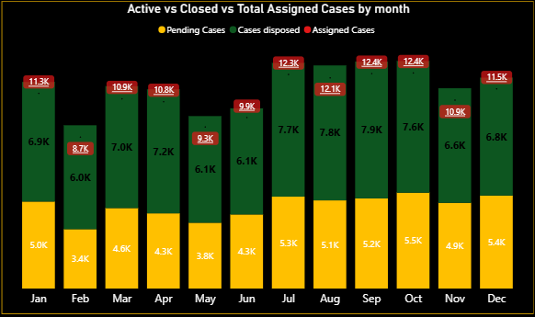

Active vs Closed vs Total Assigned Cases – Monthly Trend
Aspect | Details
Visual Type | Line & Stacked Column Chart
Data Fields | X-Axis: Month  Column Y-Axis: Pending Cases, Cases Disposed  Line Y-Axis: Assigned Cases
Measure(s) Used | [Assigned Cases], [Pending Cases], [Cases Disposed]
Purpose | Track monthly distribution of assigned, pending, and disposed cases to highlight seasonal patterns and backlog behavior.
Insights | - Assigned cases peak in July–October (~12K).  - Pending cases also rise in these months → backlog accumulation.  - Disposals steady at ~6K–7K per month.  - Jan–Feb show relatively fewer cases.
Problems / Predicted Reasons | - Seasonal spikes July–Oct due to festivals/holidays → more thefts, disputes, social crimes.  - Police & courts overloaded mid-year → slower disposals → pending rises.  - Lower Jan–Feb cases may be under-reporting or faster closures.  - Possible backlog clearance drives at year-end reduce pending cases.

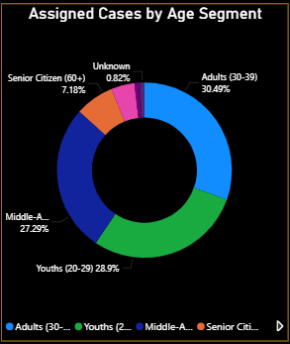

Assigned Cases by Age Segment
Aspect | Details
Visual Type | Donut Chart
Data Fields | Legend: Age Segment  Values: Assigned Cases
Measure(s) Used | [Assigned Cases]
Purpose | Identify which age groups are most affected in assigned crime cases, highlighting vulnerable segments of the population.
Insights | - Adults (30–39) = 30.5% (largest share).  - Youth (20–29) = 28.9% (closely follows adults).  - Middle-aged (40–59) = 27.3%.  - Senior citizens (60+) = 7.2%.  - Children & Unknown = very small shares.
Problems / Predicted Reasons | - Adults & youths more socially/economically active → greater exposure to assaults, fraud, workplace conflicts.  - Middle-aged victims linked to property disputes & scams.  - Senior citizens, though fewer, targeted in fraud/neglect.  - High share of youth victims signals safety concerns for students/job-seekers.  - Should cross-check with crime categories & gender for deeper insights.

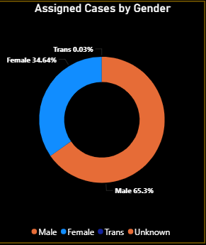

Assigned Cases by Gender
Aspect | Details
Visual Type | Donut Chart
Data Fields | Legend: Gender  Values: Assigned Cases
Measure(s) Used | [Assigned Cases]
Purpose | Understand the gender distribution of victims in assigned crime cases to highlight which gender groups are more impacted.
Insights | - Male victims = 65.3% (majority).  - Female victims = 34.6%.  - Transgender victims = 0.03% (low but reported).  - Unknown = negligible.
Problems / Predicted Reasons | - Males more exposed in outdoor/public spaces (workplace, travel, traffic) → higher theft/assault risk.  - Females more linked to domestic violence, harassment, and gender-specific crimes.  - Transgender victims low due to under-reporting or smaller population share, though awareness is improving.  - Policy concern: Youth + Adults (20–39 yrs) overlap with male dominance → working-age males most vulnerable.  - Female share still significant → signals gender-based safety risks.

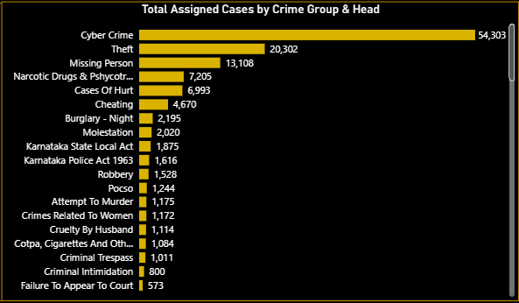

Total Assigned Cases by Crime Group & Head
Aspect | Details
Visual Type | Clustered Bar Chart
Data Fields | X-Axis: [Assigned Cases ]  Y-Axis: Crime Group, Crime Head, Act Description, Sec Description
Measure(s) Used | [Assigned Cases]
Purpose | Show distribution of assigned cases across different crime groups and heads to identify the most prevalent categories.
Insights | - Cyber Crime = 54,303 (dominant).  - Theft = 20,302; Missing Person = 13,108.  - Narcotics & Psychotropic Cases = 7,205.  - Gender & Domestic Crimes (Molestation = 2,020; Cruelty by Husband = 1,114).  - Violent Crimes (Robbery, Attempt to Murder, Murder) lower but significant.  - Other Crimes (Cheating, Trespass, Intimidation) moderate.
Problems / Predicted Reasons | - Cyber Crime: Rise due to digitization, weak cyber hygiene, phishing scams.  - Theft & Missing Persons: Socio-economic issues, migration, trafficking, family disputes.  - Narcotics: Drug abuse among youth → need for stronger enforcement.  - Gender/Domestic Crimes: Socio-cultural norms, under-reporting, lack of awareness.  - Violent Crimes: Lower than cyber but still highlight public safety risks.  - Other Crimes: Everyday law & order issues; requires routine policing.

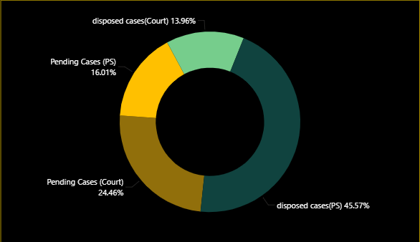
FIR Status – Pending vs Disposed Cases
Aspect | Details
Visual Type | Donut Chart
Data Fields | Legend/Category: Pending Cases (PS), Pending Cases (Court), Disposed Cases (PS), Disposed Cases (Court)
Measures Used | [Disposed Cases (Court)], [Disposed Cases (PS)], [Pending Cases (Court)], [Pending Cases (PS)]
Purpose | Track case disposal efficiency at Police Station (PS) and Court levels, and identify where delays are happening.
Insights | - Disposed Cases (PS): 45.6% → Nearly half resolved at PS level (good sign).  - Pending Cases (Court): 24.5% → Largest backlog.  - Pending Cases (PS): 16% → Moderate, linked to investigation delays.  - Disposed Cases (Court): 14% → Very low compared to pending court cases.
Problems / Predicted Reasons | - Court Backlog: Judicial delays, shortage of judges, adjournments, procedural complexity.  - PS Backlog: Incomplete investigations, weak evidence, staff shortages.  - Court Disposal Low: Cases pile up in trial stage; courts less efficient than PS.
What Needs to Improve | - Speed up judicial process: fast-track courts, more judges, digital case systems.  - Better coordination between PS & courts for timely evidence/chargesheets.  - Monitor high-pendency courts, allocate more resources.  - Set disposal targets (e.g., ≥70% within 12 months).

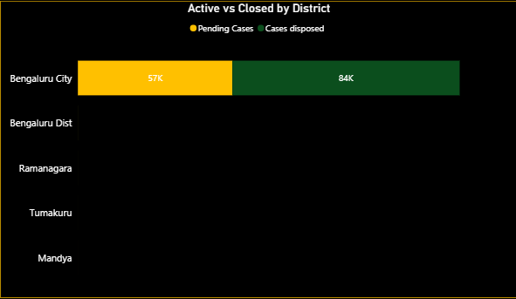
Active vs Closed by District
Aspect | Details
Visual Type | Stacked Bar Chart
Data Fields | Y-Axis: District_Name  X-Axis: Pending Cases, Cases Disposed
Measures Used | [Cases disposed], [Pending Cases]
Purpose | Compare pending vs disposed FIR cases across districts, identify backlog hotspots, and guide resource allocation.
Insights | - Bengaluru City: 57K pending vs 84K disposed → strong disposal but backlog still very high.  - Other districts (Bengaluru Dist, Ramanagara, Tumakuru, Mandya): lower volumes but significant pending relative to disposed.  - Bengaluru City dominates both pending & disposed, reflecting higher caseload and efficiency compared to smaller districts.
Problems / Predicted Reasons | - Bengaluru City: Huge absolute backlog despite strong performance, likely due to massive inflow of cases.  - Smaller districts (Tumakuru, Mandya): Low disposal efficiency, possibly staff shortage, investigation bottlenecks, or judicial delays.
What Needs to Improve | - Bengaluru City: Add more judicial/police staff, introduce backlog clearance drives.  - Smaller districts: Conduct audits to identify bottlenecks; deploy additional resources.  - Use technology-driven tracking systems to monitor pending cases.  - Review YoY trend to check if backlog is reducing or worsening.

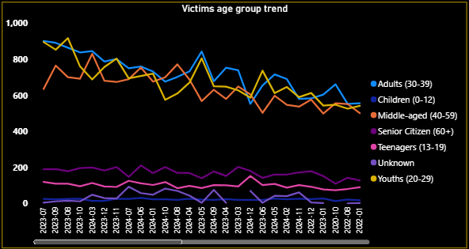

Victims Age Group Trend (Monthly Analysis)
Aspect | Details
Visual Type | Line Chart
Data Fields | X-Axis: Year-Month  Y-Axis: [Assigned Cases]  Legend: Victim Age Segment
Measures Used | [Assigned Cases]
Purpose | Identify vulnerable age groups, track monthly fluctuations, and detect seasonal victimization patterns to guide targeted interventions.
Insights | - Adults (30–39) and Children (0–12) record the highest cases → most vulnerable groups.  - Youths (20–29): strong presence but slightly lower.  - Teenagers (13–19) and Seniors (60+): consistently lower, more stable.  - Strong month-to-month fluctuations → seasonal/social influences (festivals, migration, school/college cycles).  - Recent convergence: Adults & Children trending closer to Youth levels → may reflect policy interventions or reporting changes.
Problems / Predicted Reasons | - Children (0–12): High vulnerability → trafficking, abuse, neglect, weak child safety enforcement.  - Adults (30–39): High exposure due to workplace stress, financial fraud, domestic violence.  - Volatile trends: Preventive mechanisms not consistent.
What Needs to Improve | - Strengthen child protection systems (school monitoring, helplines, awareness drives).  - Targeted support for adults (30–39) → workplace safety, domestic violence support, financial crime prevention.  - Seasonal crime prediction: allocate resources during peak months.  - Link with Crime Type Analysis to find which crimes affect children vs adults.  - Community awareness programs tailored to children, parents, and working-age adults.

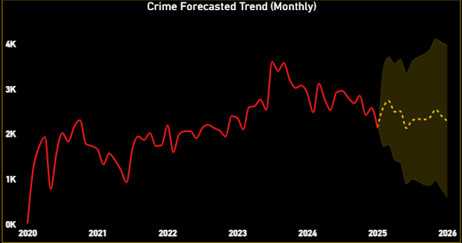
Crime Forecasted Trend (Monthly)
Aspect | Details
Visual Type | Line Chart
Data Fields | X-Axis: YearMonthStart, Year, Quarter, Month, Day  Y-Axis: Assigned Cases
Measures Used | [Assigned Cases]
Formatting & Design | Forecast length: 12 months  Confidence Interval: 95%  Confidence Shade: Yellow  Forecast Line: Yellow dotted  Historical Trend: Red solid  Upper Bound = Worst-case  Lower Bound = Best-case
Purpose | To project future monthly crime cases with confidence ranges, helping stakeholders prepare for both most-likely and extreme-case scenarios.
Insights | - Historical (2020–2024): Upward trend peaking >3,500 cases/month.  - Forecast (2025–2026): Stabilization expected, but still high.  - Q2 2025 Example: Avg. forecast = 2,485 cases/month;  - Upper bound = 3,551; Lower bound = 1,420.  - Wide confidence band → uncertainty, requiring cautious planning.
Problems / Predicted Risks | - Police workload to remain consistently high.  - Big swing in forecasts (±1,000+) means unpredictability in monthly caseload.
Recommendations | - Allocate resources based on upper bound to avoid under-preparation.  - Strengthen crime prevention programs to move actuals closer to lower bound.  - Continuously compare actual vs forecast to fine-tune model accuracy.

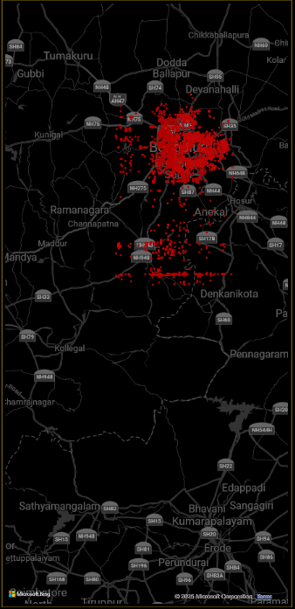

CRU Crime Analytics – Spatial View
Aspect | Details
Visual Type | Map
Data Fields | Latitude: lat_Final  Longitude: Long_Final  Bubble Size: Assigned Cases  Tooltip: UnitName
Measures Used | [Assigned Cases]
Purpose | To show spatial distribution of crime incidents across the region, identify hotspots, and compare intensity between urban and rural police jurisdictions.
Insights | - Bengaluru & surrounding urban centers show the highest case density.  - Peripheral towns (Tumakuru, Doddaballapur, Anekal) have smaller case volumes.  - Heat concentration proves urban centers are more crime-heavy.  - Time-slider (0–23 hrs) adds an extra layer of analysis (day vs night crime patterns).
Problems / Predicted Risks | - Urban police stations are overloaded with high caseloads.  - Rural areas may be under-reported but still face critical crime types.  - Resource imbalance between high-density vs low-density regions.
Recommendations | - Deploy more manpower & resources in urban hotspots.  - Use time-of-day trends to optimize police patrol schedules.  - Enhance coordination across districts for inter-jurisdiction crimes.  - Launch crime prevention & awareness drives in high-density areas like Bengaluru.

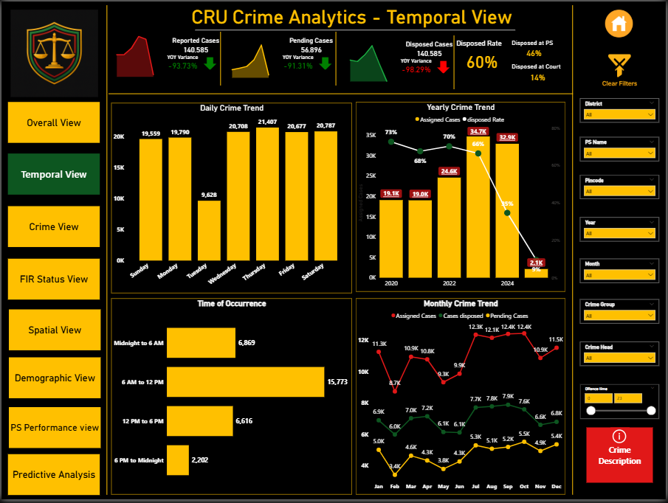

Daily Crime Trends (Weekday-wise Assigned Cases)
Aspect | Details
Visual Type | Stacked Column Chart
Data Fields | X-Axis: Day_Name  Y-Axis: [Assigned Cases]
Measures Used | [Assigned Cases]
Purpose | - Show workload distribution of assigned cases across weekdays.  - Identify peak days for crime assignment.  - Support resource planning and operational deployment.
Insights | - Thursday highest workload (21,407 cases).  - Saturday also high (20,487 cases).  - Tuesday lowest (9,628 cases).  - Other weekdays: moderate range (10K–18K).  - Pattern: mid-to-late week (Thu–Sat) busier vs early week (Mon–Tue quieter).
Problems / Predicted Reasons | - Thursday peak → weekly review cycles, backlog pushed midweek.  - Saturday spike → weekend crimes (disturbances, theft, traffic) + pre-weekend assignments.  - Tuesday dip → fewer fresh cases post-weekend; backlog clears on Mon/Wed.  - Imbalance → resource strain on Thu–Sat, underutilization on Mon–Tue.
Recommendations | - Spread case assignment evenly across weekdays.  - Break down crime types per weekday to confirm cause of peaks.  - Align manpower & patrol deployment with Thu–Sat peaks.  - Use automation to reduce clustering.  - Monitor monthly/seasonal patterns to check if weekday imbalance is consistent.

Yearly Crime Trends – Assigned Cases vs Disposed Rate
Aspect | Details
Visual Type | Line & Clustered Column Chart
Data Fields | X-Axis: Year  Column (Y1): [Assigned Cases]  Line (Y2): [Disposed Rate]
Measures Used | [Assigned Cases], [Disposed Rate]
Purpose | Compare yearly crime assignment volumes with disposal efficiency, to evaluate whether rising caseloads impact case clearance.
Insights | - 2023: Highest assignment (34.7K) but disposal only 66%.  - 2020: Best disposal efficiency (73%) despite moderate caseload (19.1K).  - 2021–22: Steady performance (~19K–24K cases, 68–70% disposal).  - 2024: Assignment spiked to 32.9K but disposal collapsed to 35%.  - 2025 (YTD): Very low assignment (2.1K) but alarming disposal efficiency (9%) — possibly incomplete data.  - Evidence: Higher caseload years → disposal efficiency falls sharply.
Problems / Predicted Reasons | - 2024 Backlog → spike in cases overburdened system.  - 2025 Low Disposal → partial year, backlog still unresolved.  - Volume vs Efficiency mismatch → 2020 & 2022 efficient despite moderate volume, so resource/process bottlenecks are also factors.  - Lack of breakdown by crime type → complex crimes may skew disposal rates.
Recommendations | - Investigate 2024 backlog drivers (policy change, staff shortage, rise in cybercrime/fraud).  - Benchmark best years (2020, 2022) → replicate successful strategies.  - Add drill-through by crime group for deeper efficiency insights.  - Implement workload balancing in high-volume years.

Crime Trends by Time of Occurrence – Assigned Cases
Aspect | Details
Visual Type | Stacked Bar Chart
Data Fields | Y-Axis: Time Range  X-Axis: Assigned Cases  Legend: Unit Name (Police Unit/Department)
Measures Used | [Assigned Cases]
Purpose | Analyze case assignment trends by time of day to identify peak hours, workload distribution, and resource needs across units.
Insights | - Morning (6AM–12PM): Highest case load (15,773) → majority of crimes reported/assigned in morning.  - Midnight–6AM: Second highest (6,869) → indicates significant late-night incidents.  - Afternoon (12PM–6PM): Moderate (6,616).  - Evening/Night (6PM–Midnight): Lowest (2,202) → suggests underreporting or reporting delays.  - Trend: Sharp morning peak, dip in afternoon, very low evening assignment.
Problems / Predicted Reasons | - Morning Peak → delayed reporting of night crimes.  - Midnight–6AM High → late-night thefts, assaults, alcohol-related incidents.  - Low Evening (6PM–Midnight) → underreporting due to fear, lack of access, or preference to report next morning.  - Reporting bias → chart shows assignment time, not exact occurrence time.  - Crime-type differences hidden in aggregate (e.g., cybercrime may not follow same pattern).
Recommendations | - Increase late-night patrols (12AM–6AM) to match crime load.  - Strengthen morning intake (6AM–12PM) by deploying more station staff.  - Awareness drives to encourage evening reporting instead of delaying until morning.  - Add crime-type breakdown by time to reveal category-specific peaks.  - Use predictive staffing models → align manpower with reporting spikes.
Monthly Crime Trends
Aspect | Details
Visual Type | Line Chart
Data Fields | X-Axis: Month (Jan–Dec)  Y-Axis: Assigned Cases, Disposed Cases, Pending Cases
Measures Used | [Assigned Cases], [Cases disposed], [Pending Cases]
Purpose | Track month-by-month variation in case assignment, disposal, and pending backlog. Helps uncover seasonal patterns and check if enforcement is keeping up with caseloads.
Insights | - Assigned Cases: Peaks in Oct (12.4K), Jul (12.3K), Sep (12.3K) → seasonal surges. Lowest in Feb (8.7K).  - Disposed Cases: Range 6.1K–7.9K, with best clearance Jul–Sep (>7.5K).  - Pending Cases: Low in Feb (3.4K), but rises sharply in Oct–Dec (>5K).  - Biggest Gap: Oct → 12.4K assigned vs 7.6K disposed → backlog 5.4K (worst month for system stress).
Problems / Predicted Reasons | - Backlog surge (Oct–Dec): Likely end-of-year crime/reporting spike + limited disposal bandwidth.  - Feb dip: Seasonal reduction (short month, festivals, lower outdoor activity).  - Disposals not scaling with assignments → structural bottlenecks in investigation or court process.  - Sustained Pending (5K+) indicates systemic delays beyond seasonal fluctuation.
Recommendations | - Boost staffing/resources during Jul–Oct high-load months.  - Conduct backlog audits for Oct–Dec → courts, police, or evidence bottlenecks?  - Compare YoY monthly trends → identify recurring seasonal spikes.  - Use Power BI Forecasting to anticipate pending load in upcoming months.

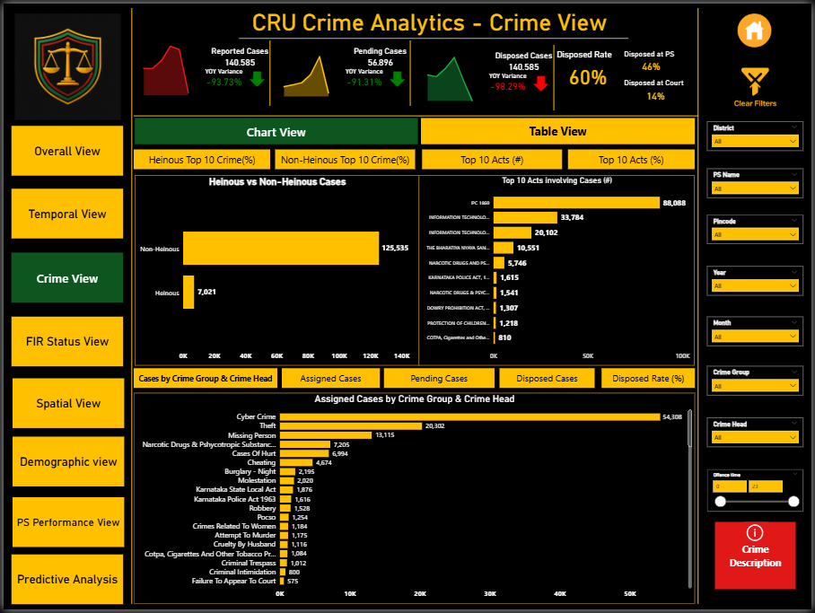

Crime View (Chart View)
Button | Bookmark Triggered | Visuals Shown | Visuals Hidden | Notes
Heinous Top 10 Crimes | HeinousTop10_BM | Top 10 Heinous Crimes (bar chart) | Non-Heinous Top 10, Top 10 Acts, Group-level charts | Focus on severe crimes
Non-Heinous Top 10 Crimes | NonHeinousTop10_BM | Top 10 Non-Heinous Crimes (bar chart) | Heinous Top 10, Top 10 Acts, Group-level charts | Highlights frequent but less severe crimes
Top 10 Acts (#) | Top10ActCount_BM | Top 10 Acts by number of cases | Heinous/Non-Heinous, Top 10 Act (%), Group-level charts | Raw case count
Top 10 Acts (%) | Top10ActPercent_BM | Top 10 Acts by % share | Heinous/Non-Heinous, Top 10 Act (#), Group-level charts | Shows contribution to total
Cases by Crime Group & Category | CasesByGroupCat_BM | Assigned/Disposed/Pending by group & category | All other bookmarks | Group-level split
Assign Cases by Crime Group | AssignCasesGroup_BM | Assigned cases by crime group | Others | Workload comparison
Pending Cases by Crime Group | PendingCasesGroup_BM | Pending cases by crime group | Others | Shows backlog
Disposed Cases by Crime Group | DisposedCasesGroup_BM | Disposed cases by crime group | Others | Efficiency indicator
Disposed Cases (%) by Crime Group | DisposedRateGroup_BM | Disposal % by crime group | Others | KPI for efficiency

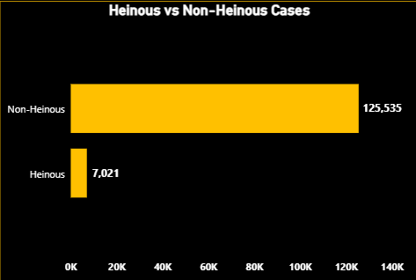

Heinous vs Non-Heinous Cases
Aspect | Details
Visual Type | Clustered Bar Chart
Data Fields | X-Axis: Assigned Cases (No. of FIRs)  Y-Axis: FIR Type (Heinous / Non-Heinous)
Measures Used | [Assigned Cases]
Purpose | Compare distribution between heinous and non-heinous crimes, show dominance of non-heinous in total reporting, and provide a drill-down base for age, crime type, and demographics.
Insights | - Non-Heinous Cases: 125,535 (≈94% of total).  - Heinous Cases: 7,021 (≈6%).  - Non-heinous dominates overall, but heinous cases demand higher effort despite lower volume.  - Localized filters (district, crime group) can change proportions.
Problems / Predicted Reasons | - Dilution of focus: Huge non-heinous load (petty theft, disputes, cyber fraud) may reduce attention on heinous crimes.  - Heinous underreporting: Fear, stigma, or inefficiency may hide true volume.  - Investigation challenge: Heinous crimes require deeper, time-intensive investigation vs. petty cases.
Recommendations | - Create separate task forces for heinous vs non-heinous to balance workloads.  - Fast-track courts & special units for heinous cases.  - Apply predictive analytics to detect rising non-heinous crime trends (e.g., cybercrime, theft hotspots).  - Run awareness campaigns to improve reporting of heinous crimes.

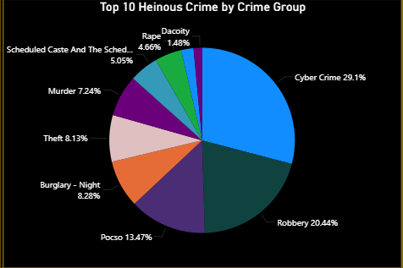

Top 10 Heinous Crimes
Aspect | Details
Visual Type | Pie Chart (distribution view)
Data Fields | Legend: CrimeGroup_Name  Values: Assigned Cases  Filters: FIR Type = Heinous  CrimeGroup_Name 10 by Assigned Cases
Measures Used | [Assigned Cases]
Purpose | Identify which heinous crimes dominate reported cases, compare distribution across top crime groups, and highlight focus areas for policing.
Insights | - Cyber Crime: 29.1% (largest share).  - Robbery: 20.4% (second-highest).  - POCSO: 13.5% (serious child-related crimes).  - Burglary at Night (8.3%) & Theft (8.1%) still notable.  - Murder: 7.2%.  - Top 3 (Cyber + Robbery + POCSO) = ~63% of all heinous crimes.
Problems / Predicted Reasons | - Cybercrime surge → lack of strong monitoring & awareness in online safety.  - Robbery prevalence → public space safety & weak deterrence.  - POCSO rise → inadequate child protection & awareness.  - Murder/Burglary → localized law & order challenges.
Recommendations | - Cyber: Expand digital forensics, cyber law enforcement, and citizen training.  - Robbery: Increase patrols, surveillance (CCTV), and hotspot policing.  - POCSO: Strengthen child protection cells, school safety programs, and fast-track courts.  - Burglary/Theft: Improve neighbourhood watch & night policing.

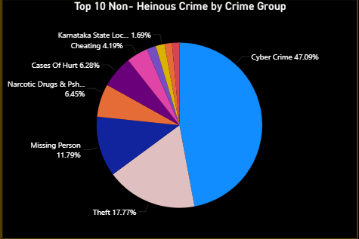

Top 10 Non-Heinous Crimes
Aspect | Details
Visual Type | Pie Chart
Data Fields | Legend: Crime Group Name  Values: [Assigned Cases]  Filters: FIR Type = Non-Heinous  Crime Group Name Top 10 by Assigned Cases
Measures Used | [Assigned Cases]
Purpose | To highlight the most common non-heinous crimes and compare their share in overall distribution, focusing on high-frequency but less severe cases.
Insights | - Cyber Crime: 47.1% → almost half of all non-heinous cases.  - Theft: 17.8%.  - Missing Person: 11.9%.  - Narcotic Drugs & Psychotropic Substances: 6.5%.  - Cases of Hurt: 6.3%.  - Cheating: 4.2%.  - Local Act violations: < 2%.
Problems / Predicted Reasons | - Cybercrime dominance → weak cyber hygiene & lack of citizen awareness.  - Theft & Missing Persons → high frequency creates police workload pressure.  - Drugs → signals youth vulnerability and trafficking networks.
Recommendations | - Expand cyber awareness campaigns & IT policing cells.  - Strengthen community policing & surveillance to reduce theft/missing persons.  - Collaborate with health & social services to fight drug abuse.  - Introduce preventive measures to reduce repeat petty crimes and backlog.

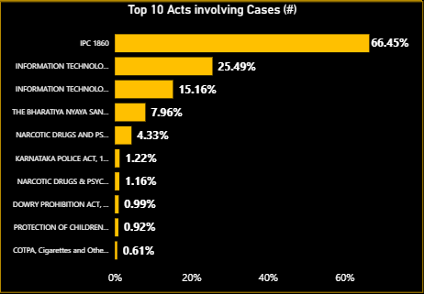

Top 10 Acts Involving Cases (%)
Aspect | Details
Visual Type | Clustered Bar Chart
Data Fields | Y-axis (Categories): Act_Description, Sec_Description  X-axis (Values): [Assigned Cases Percentage]  Filter: Act_Description Top 10 by [Assigned Cases Percentage]
Measures Used | [Assigned Cases Percentage]
Purpose | To show which legal Acts are most frequently invoked in FIRs. Provides insight into the legal areas where crime concentration is highest, guiding both law enforcement focus and policy reform priorities.
Insights | - IPC 1860 dominates → core of criminal justice system, applied to most FIRs.  - IT Act 2000 → cyber fraud, hacking, identity theft; gaining importance in digital era.  - IT Act 2008 (Amendment) → addresses cyber terrorism, phishing, data protection.  - Bharatiya Nyaya Sanhita (BNS) 2023 → modern framework replacing parts of IPC, focusing on digital/organized crimes.
Problems / Predicted Reasons | - IPC’s dominance overshadows smaller but critical Acts.  - IT Act 2000 vs 2008 overlap may confuse reporting/analysis.  - Only % share shown → actual case volumes not visible.  - Lacks clarity on crime severity within Acts.
Recommendations | - Add dual-axis (count + %) for transparency.  - Group IT Act 2000 & IT Act 2008 under a unified “Cybercrime Acts” category.  - Build trend analysis by year for each Act → shows legal relevance evolution.  - Apply color coding (IPC, IT, BNS) for readability.  - Add drill-through by Sections to uncover case details (e.g., IPC 302 → murder cases).

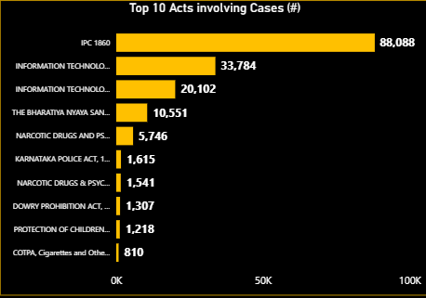

Top 10 Acts Involving Registered Cases
Aspect | Details
Visual Type | Clustered Bar Chart
Data Fields | Y-axis: Act Description, Section Description  X-axis: Assigned Cases  Filters: Top 10 Acts by Assigned Cases
Measures Used | [Assigned Cases]
Purpose | - Identify Acts of law that dominate registered cases.  - Highlight the legal frameworks most invoked in FIRs.  - Guide policy & judicial resource allocation where workloads are concentrated.
Insights | - IPC 1860: 88,088 cases → absolute majority.  - IT Act 2000 (33,784) + IT Act 2008 (20,102) → cybercrime cluster rising fast.  - Bharatiya Nyaya Sanhita (BNS) 2023: 10,551 cases, showing quick adoption post-reform.  - NDPS Act (5,746) → persistent drug offences.  - Other notable contributions: Karnataka Police Act (1,615), Dowry Prohibition Act (1,307), POCSO (1,218).  - Together, IPC + IT Acts ≈ 70% of Top 10 Acts, showing concentration around general criminal and cyber domains.
Problems / Predicted Reasons | - Heavy IPC usage → backlog pressure on courts.  - IT Act surge → cyber offences expanding beyond policing capacity.  - NDPS/Dowry → entrenched social issues, not just legal gaps.  - POCSO, though smaller in number, signals sensitive crimes needing faster disposal.
Recommendations | - Judicial fast-track for IPC-heavy caseloads.  - Strengthen cyber forensic cells & IT law enforcement for IT Act cases.  - Awareness + rehab programs for NDPS-related offences.  - Expand child protection cells to monitor & speed up POCSO cases.  - Legal modernization: simplify overlapping IPC sections, streamline BNS adoption.

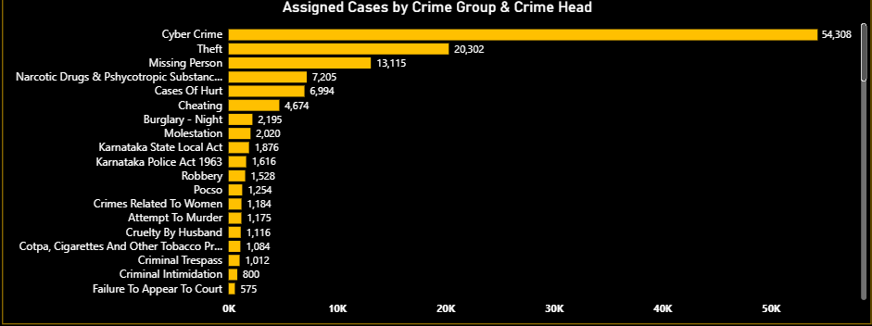
Assigned Cases by Crime Group & Crime Head
Aspect | Details
Visual Type | Clustered Bar Chart
Data Fields | Y-axis: CrimeGroup_Name, CrimeHead_Name  X-axis: [Assigned Cases]
Measures Used | [Assigned Cases]
Purpose | - To analyze the distribution of assigned cases across different crime groups and heads.  - To identify categories contributing the most to police workload.
Key Insights | - Cyber Crime: 54,308 cases (largest share).  - Theft: 20,302 cases.  - Missing Person: 13,115 cases.  - NDPS-related crimes: 7,205 cases.  - Cases of Hurt: 6,994 cases.  - Failure to Appear in Court and Criminal Intimidation show relatively lower counts.  - Overall, a few categories (Cyber, Theft, Missing Persons) dominate case load disproportionately.
Problems / Predicted Reasons | - Overcrowded chart: Too many categories → harder for users to interpret at once.  - Small-value crimes invisible: Low-frequency bars overshadowed by major ones.  - No % contribution: Raw counts only, no sense of proportion.  - No time context: Users cannot see trends/seasonality.
Recommendations | - Add a Top 10 crimes filter to improve focus.  - Create a 100% stacked bar view for proportion comparison.  - Enable hierarchical drill-down (Crime Group → Crime Head → Crime Section).  - Add trend tooltips (monthly/yearly breakdown when hovering).  - Include a benchmark line (e.g., average assigned cases per crime head) for better workload comparison.

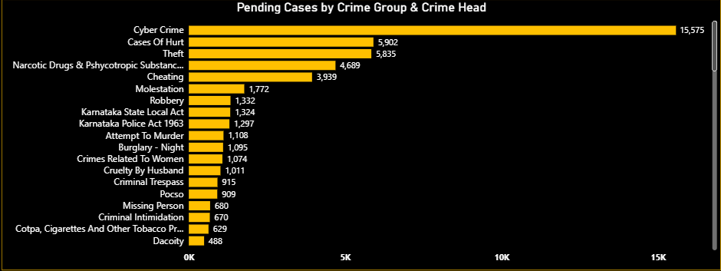

Pending Cases by Crime Group & Crime Head
Aspect | Details
Visual Type | Clustered Bar Chart
Data Fields | Y-axis (Categories): CrimeGroup_Name, CrimeHead_Name  X-axis (Values): [Pending Cases]
DAX Measures Used | [Pending Cases]
Purpose | - To provide an overview of backlog in cases, showing which crime groups/heads face delays.  - To help prioritize resources for high-pending categories.
Key Insights | - Cyber Crime backlog is the largest among all categories.  - Theft and Missing Person cases also show significant pending volumes.  - NDPS Act and Cases of Hurt maintain steady pending loads, adding to the long-term backlog.  - Lesser categories (Failure to Appear in Court, Criminal Intimidation) show smaller pending counts but may still create bottlenecks due to their sensitive nature.  - Clear imbalance: a handful of categories dominate total pending cases.
Problems / Predicted Reasons | - Case overload in Cyber & Theft → Backlog worsens due to investigation complexity and evidence collection delays.  - Court dependency → Cases stuck under "Pending@Court" inflate backlog, especially in NDPS and POCSO categories.  - Visualization issue → Too many bars, making small pending categories invisible.  - No temporal split, so users cannot track whether pending stock is increasing or reducing over time.
Recommendations | - Add a Top 10 Pending Crimes filter to declutter view.  - Enable drill-through by Crime Group → Crime Head → Court/PS pending split.  - Add trend over time to monitor backlog growth vs clearance.  - Prioritize high-pending groups (Cyber, Theft, Missing Person) for targeted clearance drives.

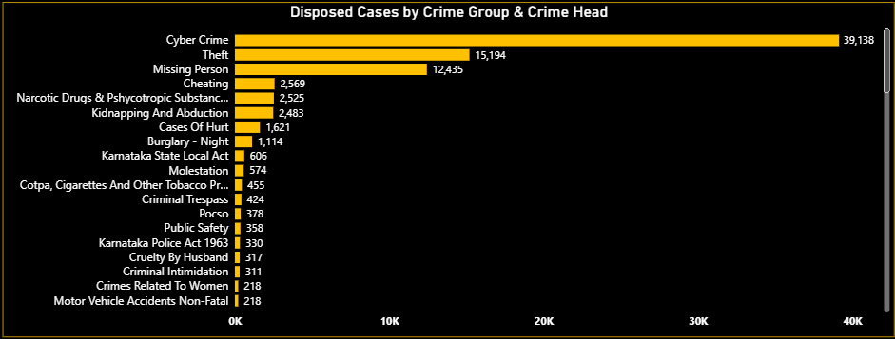Disposed Cases by Crime Group & Crime Head
Aspect | Details
Visual Type | Clustered Bar Chart
Data Fields | Y-axis: CrimeGroup_Name, CrimeHead_Name  X-axis: [Cases Disposed]
Measures Used | [Cases disposed]
Purpose | - Track closure progress of cases across different crime groups.  - Identify which crimes are resolved efficiently vs. lagging behind.  - Provide performance insight on law enforcement workload handling.
Insights | - Cyber Crime: 39,138 disposed → highest, reflecting strong follow-up.  - Theft: 15,194 disposals, second-highest.  - Missing Person: 12,435 disposals → efficient clearance compared to pending load.  - Low disposals in sensitive categories: Burglary at Night (1,114), Molestation (574), Motor Vehicle Accidents Non-Fatal (218).  - Overall: focus remains on high-volume crimes, while smaller but critical categories lag.
Problems / Predicted Reasons | - Only absolute disposal counts shown → no efficiency % vs. assigned/pending.  - No time-series → can’t track disposal trend.  - Sensitive cases (Molestation, Crimes Against Women) show very low disposals.  - Lack of benchmark or ratio hides true clearance performance.

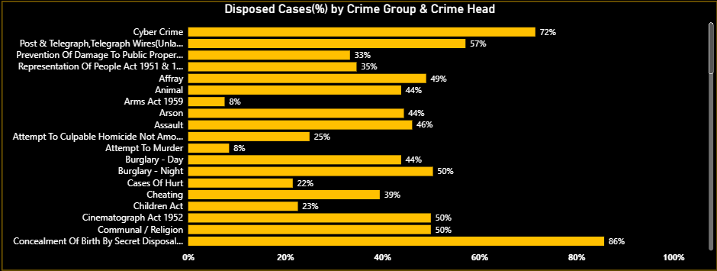Disposed Cases (%) by Crime Group & Crime Head
Aspect | Details
Visual Type | Clustered Bar Chart
Data Fields | Y-axis: CrimeGroup_Name, CrimeHead_Name  X-axis: [Disposed Rate]
Measures Used | [Disposed Rate]
Purpose | - Show what percentage of assigned cases are being disposed.  - Compare clearance efficiency across crime categories.
Insights | - Concealment of Birth → 86% (highest).  - Cyber Crime → 72% despite very high assigned cases (strong performance).  - Post & Telegraph/Telecommunication → 57% (above average).  - Children Act, Cinematograph Act, Religion crimes → ~50% (moderate).  - Serious crimes like Attempt to Murder (25%), Culpable Homicide Attempt (25%), Arms Act (8%), Burglary (44%) show very poor clearance.  - Crimes Against Women (e.g., Molestation) not visible → need deeper check.

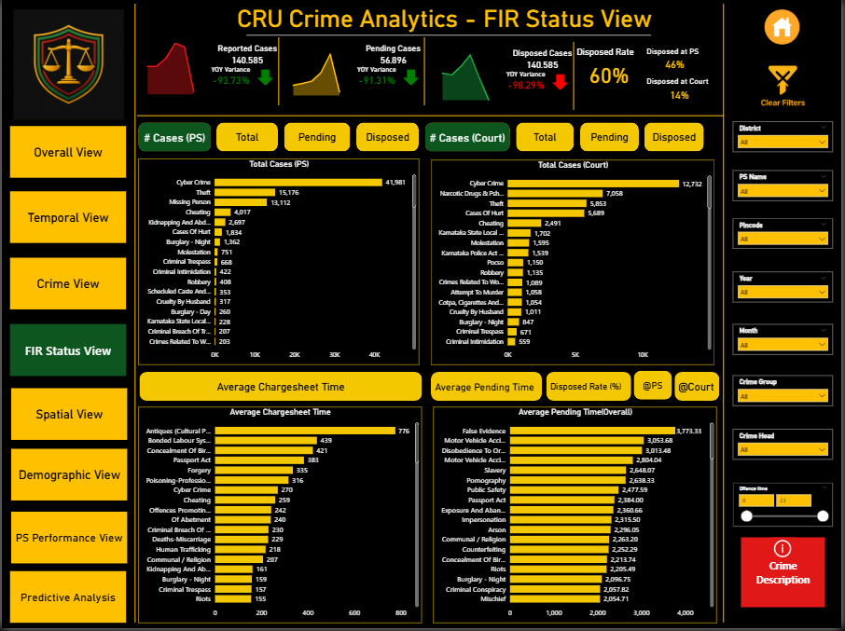
Button | Bookmark Triggered | Visuals Shown | Visuals Hidden | Notes
Victim Top 10 | VictimTop10_BM | Top 10 victim categories (bar chart) | Victim Top 20, Victim Profile, Offender visuals | High-level victim view
Victim Top 20 | VictimTop20_BM | Top 20 victim categories (bar chart) | Victim Top 10, Victim Profile, Offender visuals | More detail
Victim Profile | VictimProfile_BM | Victim demographic profile (Age, Gender, Occupation, etc.) | Victim Top 10, Victim Top 20 | Structural demographics
Offender Top 10 | OffenderTop10_BM | Top 10 offender categories | Offender Top 20, Offender Total, Victim visuals | High-level offender view
Offender Top 20 | OffenderTop20_BM | Top 20 offender categories | Offender Top 10, Offender Total, Victim visuals | Detailed analysis
Offender Total | OffenderTotal_BM | Total accused count | Offender Top 10, Offender Top 20 | Overall summary

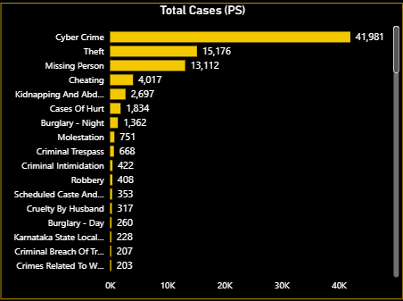

Total Cases Reported at Police Stations
Aspect | Details
Visual Type | Clustered Bar Chart
Data Fields | Y-Axis: CrimeGroup_Name, CrimeHead_Name  X-Axis: [Total Cases (PS)]
Measures Used | [Total Cases (PS)]
Purpose | - Show total number of cases at Police Station (PS) level.  - Identify which crime categories have the highest reporting volume.
Insights | - Cyber Crime → 41,981 cases (highest).  - Theft (15,176), Missing Person (13,112), Cheating (4,017) are other major categories.  - Missing Person cases form a large share but are mostly administrative, not criminal trials.
Problems / Predicted Reasons | - Cyber Crime and Theft show very high reporting, pointing to rising trends.  - Missing Person cases inflate PS statistics without actual trial-based closure.
Recommendations | - Deploy specialized cyber cells to manage large Cyber Crime volumes.  - Strengthen theft-prevention strategies.  - Build tracking system for Missing Persons (closure reason, outcome monitoring).

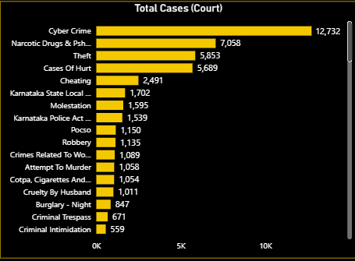

Total Cases Registered in Court
Aspect | Details
Visual Type | Clustered Bar Chart
Data Fields | Y-Axis: CrimeGroup_Name, CrimeHead_Name  X-Axis: [Total Cases (Court)]
Measures Used | [Total Cases (Court)]
Purpose | - Show the total number of cases that reach the Court stage.  - Compare which crime categories proceed from PS to trial.
Insights | - Cyber Crime → 12,732 cases (highest), but only ~30% of PS volume moves to Court.  - Theft (7,058) and Narcotics (5,853) are other leading trial categories.  - Missing Person cases are almost absent, as expected (administrative, not trial-bound).
Problems / Predicted Reasons | - Major drop from PS → Court in Cyber Crime and Cheating, suggesting weak follow-up or lack of evidence.  - High Narcotics representation in Court may reflect focused enforcement, but could create backlog risk.
Recommendations | - Strengthen transfer tracking system (PS → Court).  - Investigate why Cyber Crime and Cheating have low conversion rates (evidence gaps, digital expertise issues).  - Monitor narcotics trials closely to manage backlog.

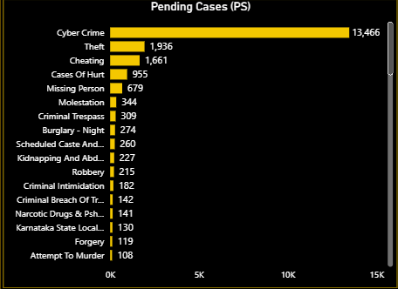

Pending Cases at Police Station (PS)
Aspect | Details
Visual Type | Clustered Bar Chart
Data Fields | X-axis: [Pending Cases (PS)]  Y-axis: CrimeHead_Name
Measures Used | [Pending Cases (PS)]
Purpose | - Show volume of cases still pending at Police Station level.  - Highlight categories with the highest backlog to guide resource allocation.
Insights | - Cyber Crime → 13,466 pending (highest).  - Theft → 1,936; Cheating → 1,661; Hurt → 955.  - Missing Person → 679 cases.  - Other mid-range pendency: Molestation (344), Criminal Trespass (309), Burglary Night (274), SC/ST Atrocities (260), Kidnapping & Abduction (227), Robbery (215).
Problems / Predicted Reasons | - Cyber Crime backlog (13k+) signals severe investigation strain.  - Theft, Cheating, and Hurt cases piling up → heavy PS-level workload.  - Sensitive crimes (Missing Person, Kidnapping, Molestation) pending → direct public safety risk.
Recommendations | - Form Cyber Crime special task force for backlog clearance.  - Prioritize pendency in Missing Person & Kidnapping to reduce victim risk.  - Fast-track Theft and Cheating using digital evidence-based processes.

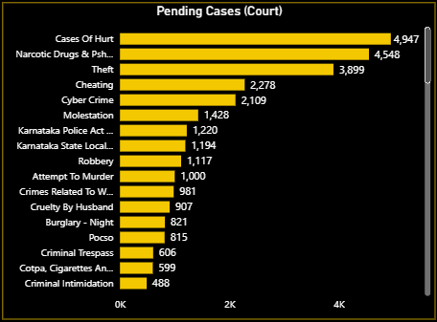

Pending Cases at Court
Aspect | Details
Visual Type | Clustered Bar Chart
Data Fields | X-axis: [Pending Cases (Court)]  Y-axis: CrimeHead_Name
Measures Used | [Pending Cases (Court)]
Purpose | - Show categories with highest case pendency at the Court level.  - Highlight backlog pressure points and sensitive case delays.
Insights | - Hurt → 4,947 (highest pendency).  - NDPS → 4,548 (second-highest).  - Theft (3,899), Cheating (2,278), Cyber Crime (2,109) form the next cluster of high-volume cases.  - Molestation → 1,428.  - Other significant pendency: Robbery (1,117), Attempt to Murder (1,100), Crimes Against Women (981), Cruelty by Husband (907), Burglary Night (821), POCSO (815).
Problems / Predicted Reasons | - Hurt & NDPS (~10k combined) dominate backlog → trials progressing very slowly.  - Theft, Cheating & Cyber Crime → major economic crimes choking court time.  - Sensitive cases (Molestation, POCSO, Women-related) pending → delay impacts justice and public trust.
Recommendations | - Set up NDPS-special courts to reduce narcotics backlog.  - Use Lok Adalats/plea bargaining for petty theft to reduce trial load.  - Introduce fast-track courts for Women & POCSO crimes.  - Promote digital evidence-based fast disposal for Cyber & Cheating cases.

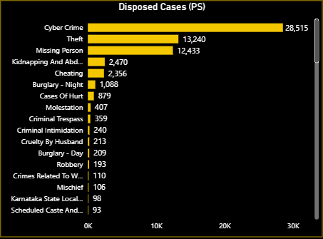

Disposed Cases at PS
Aspect | Details
Visual Type | Clustered Bar Chart
Data Fields | X-axis: [Disposed Cases (PS)]  Y-axis: CrimeGroup_Name, CrimeHead_Name
Measures Used | [ Disposed Cases (PS)]
Purpose | - Analyze which crimes are being disposed at Police Station (PS) level.  - Identify which crime categories close quickly at PS vs. which linger.  - Assess PS efficiency in handling case closures.
Insights | - Cyber Crime → 28,515 disposals (highest).  - Theft (13,240) and Missing Person (12,433) also high, showing strong PS-led resolution.  - Medium disposals: Kidnapping & Abduction (2,470), Cheating (2,356).  - Low disposals: Molestation (407), Cruelty by Husband (213), Robbery (193).  - SC/ST cases → only 93 disposed, usually escalated.
Problems / Predicted Reasons | - High disposal but weak court conversion (e.g., Cyber Crime, Theft) may indicate premature PS closure.  - Sensitive crimes (Molestation, Domestic Violence, Robbery) show very low disposals.  - SC/ST-related cases often escalated, negligible PS disposal.
Recommendations | - Audit high-volume PS disposals (Cyber Crime, Theft, Missing Person) to ensure genuine resolution.  - Create special handling units for sensitive crimes (Molestation, Domestic Violence, SC/ST).  - Train PS staff for better legal handling so disposals withstand court scrutiny.  - Policy review to prevent PS-level closures bypassing due judicial process.

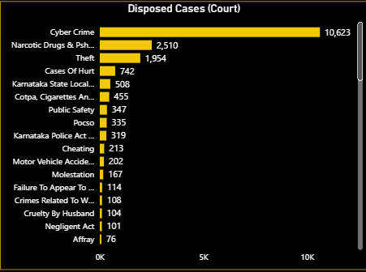

Disposed Cases at Court
Aspect | Details
Visual Type | Clustered Bar Chart
Data Fields | X-axis: [Disposed Cases (Court)]  Y-axis: CrimeHead_Name
Measures Used | [Disposed Cases (Court)]
Purpose | - Show the volume of cases disposed at the Court level.  - Identify which crime categories are seeing strong judicial resolution vs. weak disposal.
Insights | - Cyber Crime → 10,623 disposals (highest, strong focus).  - NDPS → 2,510; Theft → 1,954; Hurt → 742.  - Medium disposals: Karnataka State Local Acts (508), COTPA (455), Public Safety (347), POCSO (335).  - Very low disposals: Molestation (167), Cheating (213), Crimes Against Women (108), Cruelty by Husband (104).  - Other minor disposals: Negligent Act (101), Motor Vehicle Accident (202), Affray (76).
Problems / Predicted Reasons | - High Cyber Crime disposals but pendency (2,109) remains → heavy inflow of cases.  - NDPS, Theft, Hurt → large disposals but even bigger backlog (e.g., NDPS: 4,548 pending vs. 2,510 disposed).  - Sensitive crimes (POCSO, Molestation, Women-related) show very low disposals, raising justice delay concerns.
Recommendations | - Cyber Crime: Continue fast-track disposal, but also invest in preventive measures (digital policing, awareness, tech-enabled investigation).  - NDPS: Expand dedicated special courts; backlog exceeds progress.  - Women & Child crimes (POCSO, Molestation, Cruelty): Mandate time-bound hearings to protect victims.  - Theft & Cheating: Adopt summary trials or Lok Adalats for quicker disposal.

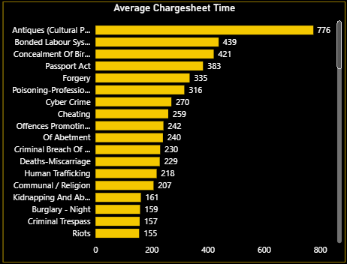

Average Chargesheet Time
Aspect | Details
Visual Type | Clustered Bar Chart
Data Fields | X-axis: Average Chargesheet Time  Y-axis: CrimeGroup_Name, CrimeHead_Name
Measure Used | [Average Chargesheet Time]
Purpose | Show avg. time (days) to file chargesheets across crimes; identify slow vs. fast categories.
Insights | - Very high: Cultural Property (776d), Bonded Labour (439d), Concealment of Birth (421d).  - Moderate: Forgery (335d), Cyber Crime (270d), Cheating (259d).  - Low: Burglary (155d), Trespass (157d), Kidnapping (161d).
Problems | - Long delays in cultural, labour & birth concealment → low priority/complex cases.  - Cyber & fraud cases delayed → weak evidence handling.
Recommendations | Fast-track units for high-delay crimes, digitization of evidence, prioritization framework, better cross-agency coordination.

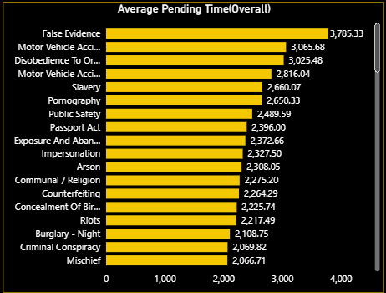

Average Pending Time (Overall)
Aspect | Details
Visual Type | Clustered Bar Chart
Data Fields | X-axis: [Average Pending Time]  Y-axis: CrimeGroup_Name, CrimeHead_Name
Measure Used | [Average Pending Time]
Purpose | Show avg. days cases remain pending in courts; highlight judicial delays and efficiency gaps.
Insights | - Very high: Arson (2,286d), Burglary-Night (2,086d), Public Property Damage (2,030d), Assault (1,876d), Animal Cruelty (1,888d).  - Cyber Crime ~1,754d (≈5 yrs).  - Moderate: Attempt to Murder (1,702d), Adulteration (1,171d), Bonded Labour (1,162d).  - Lower: Antiques (677d), Post & Telegraph (728d).
Problems | - Cyber Crime → 5 yrs pendency, risk of evidence loss.  - Violent crimes (Assault, Attempt to Murder, Arson) delayed → safety risk.  - Governance-related crimes (Adulteration, Bonded Labour) dragged for 3–4 yrs.
Recommendations | Fast-track courts for cyber/violent/economic crimes, AI-based case scheduling, digital evidence systems, prioritize violent crime trials, ADR methods for minor cases.

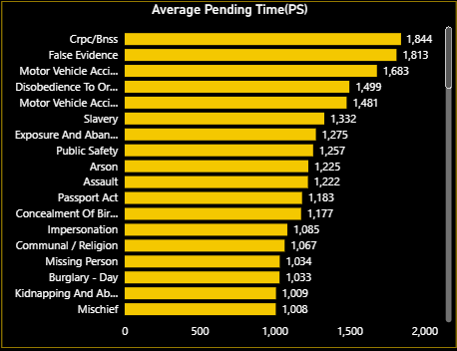

Average Pending Time (PS)
Aspect | Details
Visual Type | Clustered Bar Chart
Data Fields | X-axis: [Average Pending Time (PS)]  Y-axis: CrimeGroup_Name, CrimeHead_Name
Measure Used | [Average Pending Time (PS)]
Purpose | Track avg. days cases remain pending at Police Stations; highlight slow investigations & resource gaps.
Insights | - Very high: CrPC/BNSS (1833d), False Evidence (1802d), MVAs (1488–1470d).  - High: Slavery (1321d), Assault (1211d), Arson (1214d), Passport Act (1172d).  - Moderate: Communal/Religion (1056d), Missing Person (1023d), Burglary-Day (1022d).  - Lower: Kidnapping (998d), Mischief (997d).
Problems | - CrPC/BNSS & False Evidence → 5 yrs backlog.  - MVAs delayed 4 yrs → affects victims’ compensation.  - Serious crimes (Slavery, Assault, Arson) pending 3+ yrs.  - Sensitive cases (Missing, Kidnapping, Communal) also >1000d.
Recommendations | Special cells for MVAs & evidence-heavy cases, streamline forensic/medical processes, digitize accident claims, monitor sensitive cases closely, regular PS-level performance reviews.

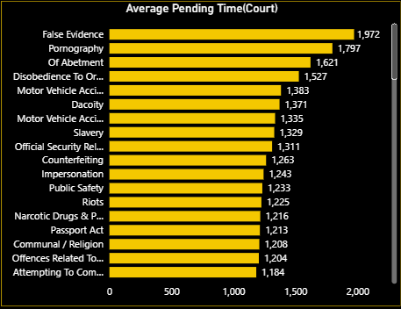

Average Pending Time (Court)
Aspect | Details
Visual Type | Clustered Bar Chart
Data Fields | X-axis: Average Pending Time (Days)  Y-axis: CrimeHead_Name
Measure Used | Average Pending Time (Court)
Purpose | Track avg. pending time in courts; highlight systemic judicial delays; assess efficiency of case disposal.
Insights | - Very high pendency: False Evidence (1962d), Pornography (1787d), Abetment (1611d), Disobedience to Orders (1517d).  - Long delays in MVAs (1325–1373d), Dacoity (1361d), Slavery (1319d).  - Sensitive crimes delayed: Riots (1215d), NDPS (1206d), Women-related offences (1194d), Communal crimes (1198d).
Problems | - Sensitive/victim-related crimes (Pornography, Women, Riots, Communal, MVAs) delayed 3–5 yrs.  - Security & narcotics cases also backlogged.  - False Evidence worst hit (5+ yrs).
Recommendations | - Fast-track courts for Pornography, Women, Riots, Communal crimes.  - Shift accident claims to tribunals.  - Special NDPS benches; digital evidence mgmt.  - ADR (Lok Adalats) for minor/financial offences.  - AI-based scheduling & digitization for backlog reduction.

Average Pending Time (Court)
Aspect | Details
Visual Type | Clustered Bar Chart
Data Fields Used | X-axis: Average Pending Time (Days)  Y-axis: CrimeHead_Name
DAX Measures Used | [Average Pending Time (Court)]
Purpose | - Shows average time cases remain pending in court.  - Highlights systemic delays.  - Tracks efficiency of case disposal.
Key Insights | - Longest delays: False Evidence (1962d), Pornography (1787d), Abetment (1611d).  - Victim-related: Motor Accidents (1325–1373d), Women-related offences (1194d).  - Security-related: Riots (1215d), Communal crimes (1198d), NDPS (1206d).  - Other long delays: Slavery, Counterfeiting, Impersonation (>3 yrs).
Problem Areas | - Sensitive crimes (Pornography, Women, Riots, Communal) pending 3–5 yrs.  - Victim-related cases (Accidents, Women) cause social & financial harm.  - Drug & security offences delayed → risk to society.
Recommendations | - Fast-track courts: Pornography, Women, Riots, Communal.  - Tribunals: Motor accident claims.  - Specialised benches: NDPS courts; digital evidence for cyber & pornography.  - ADR: Counterfeiting, impersonation → Lok Adalats.  - Technology: AI-based scheduling; digitize backlog-heavy cases.

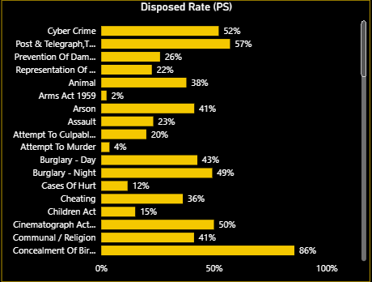

Disposed Rate (PS)
Aspect | Details
Visual Type | Clustered Bar Chart
Data Fields Used | X-axis: [Disposed Rate PS]  Y-axis: CrimeHead_Name
DAX Measures Used | [Disposed Rate (PS)]
Purpose | - To measure disposal efficiency of cases at the Police Station (PS) level.  - Helps identify strong vs weak enforcement areas.  - Highlights crime categories with high vs low clearance.
Key Insights | - Highest disposal: Concealment of Birth (86%), Post & Telegraph Act (57%), Cybercrime (52%).  - Moderate: Burglary Day (43%), Communal Offences (41%), Arson (41%).  - Low: Cheating (36%), Assault (23%), Hurt (12%), Children Act (15%).  - Critical concern: Attempt to Murder (4%), Arms Act (2%) – almost stalled.
Problem Areas | - Wide variance → 2% (Arms Act) vs 86% (Concealment).  - Heinous offences (Attempt to Murder, Arms Act, Children Act) poorly disposed.  - Common crimes (Assault, Hurt, Cheating) under-disposed (12–36%).  - Regulatory/technical cases (Cybercrime, Post & Telegraph) cleared better.
Recommendations | - Prioritize heinous crimes → fast-track Attempt to Murder, Arms Act, Children Act.  - Strengthen evidence → medico-legal, digital & witness handling training.  - Replicate success → cybercrime cells model for violent crimes.  - Accountability → weekly monitoring at DCP/SP level for low-disposal categories.

CRU Crime Analytics – Spatial View

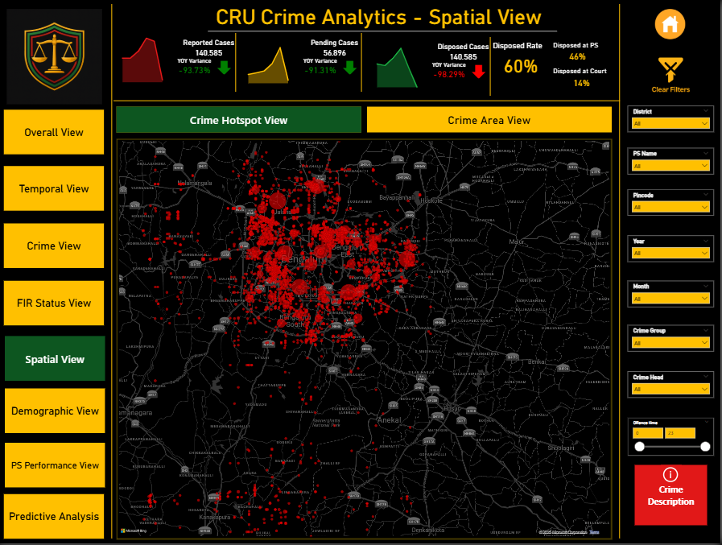

Gender wise reported cases Tooltip

Aspect | Details
Visual Type | Donut Chart (Tooltip Page)
Data Fields Used | Legend: Gender  Values: Reported Cases
DAX Measures Used | Active UNIT =  VAR _unit = SELECTEDVALUE(Fact_Crime[UnitName])  VAR _Gender = SELECTEDVALUE('victim Sex Order'[Gender])  RETURN  IF(_unit=BLANK(),_gender,_unit)  Used to dynamically display Unit Name in tooltip.
Purpose | • Provide demographic insight into reported cases by gender.  • Enhance map analysis with additional context when hovering over a bubble.  • Help compare male vs female victim distribution per Police Station (PS).

Tooltip Page – Age Segment–wise Reported Cases

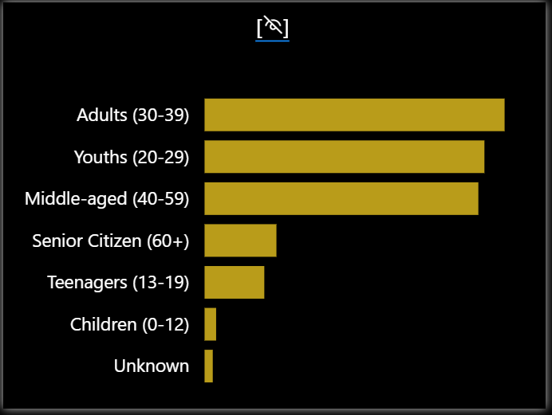
Aspect | Details
Visual Type | Clustered Bar Chart (Tooltip Page)
Data Fields Used | X-axis: Reported Cases  Y-axis: Age Segment (e.g., Child, Youth, Adult, Senior)
DAX Measures Used | Active UNIT =  VAR _unit = SELECTEDVALUE(Fact_Crime[UnitName])  VAR _Gender = SELECTEDVALUE('victim Sex Order'[Gender])  RETURN  IF(_unit=BLANK(),_gender,_unit)  Used to dynamically display Unit Name in tooltip.
Purpose | • Provide demographic breakdown of reported cases by age group.  • Support hotspot and workload analysis with victim profile insights.  • Compare case distribution across age segments for each Police Station.

Crime Hotspot View
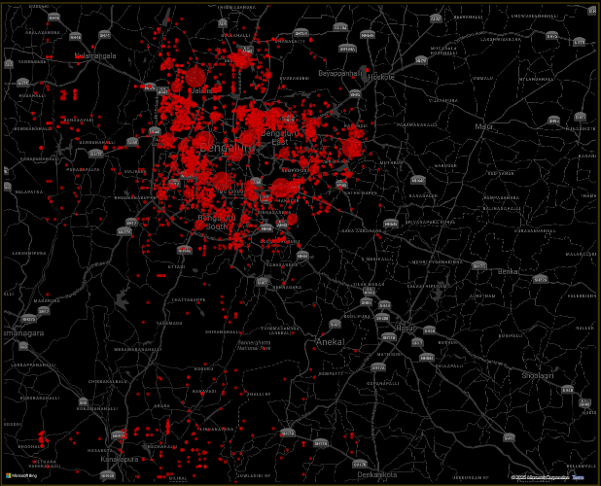
Aspect | Details
Visual Type | Map (Bubble Layer – Cluster Plot)
Data Fields Used | Latitude, Longitude, Bubble Size → Assigned Cases, Tooltip → Unit Name
DAX Measures Used | [Assigned Cases] (calculated measure for case allocation per PS/Unit)
Tooltip | • Unit Name – Police Station handling the cases.  • Assigned Cases – total workload of that station.  • Gender-wise Reported Cases (from tooltip page) – breakdown of male vs female victims.  • Dynamic Filters Applied – Pincode, Crime Group, Crime Head, Year/Month.
Purpose | • To visualize spatial distribution of assigned cases.  • Identify crime hotspots and regional concentration.  • Compare workload intensity across Police Stations (PS).
Key Insights | • Major clustering visible in central Bengaluru – indicates high crime density.  • Peripheral regions (Anekal, Ramanagara, Kanakapura) show smaller but spread-out cases.  • Certain PS units manage disproportionately higher caseloads.  • Tooltip reveals gender bias in reported cases, aiding demographic insights.
Problem Areas | • Overburdened PS units in central city – may strain enforcement capacity.  • Rural/outer PS units show fewer but scattered cases – may cause resource allocation inefficiency.  • Gender-wise data shows imbalance (e.g., higher reporting among women in urban PS, but underreporting in rural areas).
Recommendations | • Deploy additional staff/resources to PS with highest bubble density.  • Use hotspot data to plan targeted patrols in high-crime pockets.  • Address gender-based crime trends → women helpdesks, awareness in rural areas.  • Leverage peripheral PS with spare capacity to support overburdened ones.

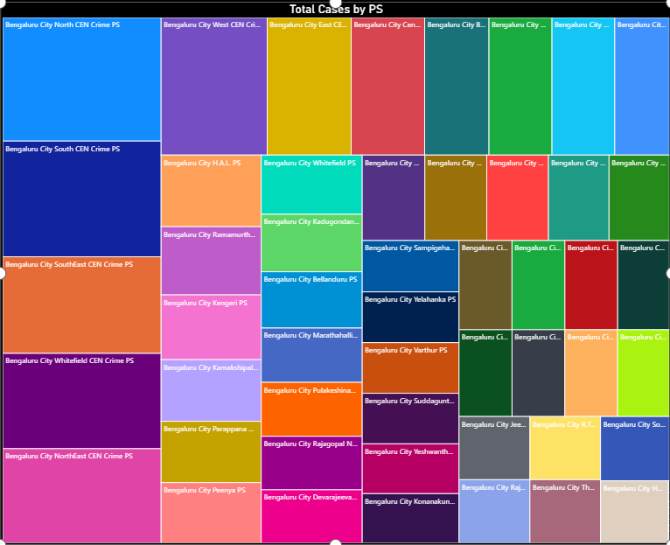
Aspect | Details
Visual Type | Tree Map
Data Fields Used | Category: District_Name, UnitName, Village  Values: Assigned Cases
Purpose | • To compare the proportion of total cases across different PS/Units.  • Quickly highlight which PS contributes most to the total caseload.  • Provide a hierarchical view (District → Unit → Village).
Key Insights | • Bengaluru City occupies the largest block, indicating significantly higher caseload than other districts.  • Other districts/PS appear smaller, showing lesser contribution to overall cases.  • Visual imbalance indicates crime is not evenly distributed across PS units.
Problem Areas | • Central urban PS are heavily loaded, creating enforcement strain.  • Rural/outer PS show low but scattered case distribution.  • Lack of case distribution balance between urban and rural units.
Recommendations | • Prioritize staffing in Bengaluru City PS to manage high workload.  • Investigate underlying reasons (population density, commercial areas, hotspots) behind the high case volume.  • Redistribute cases/resources to underutilized PS where possible.  • Use the treemap to regularly monitor changes in caseload distribution.

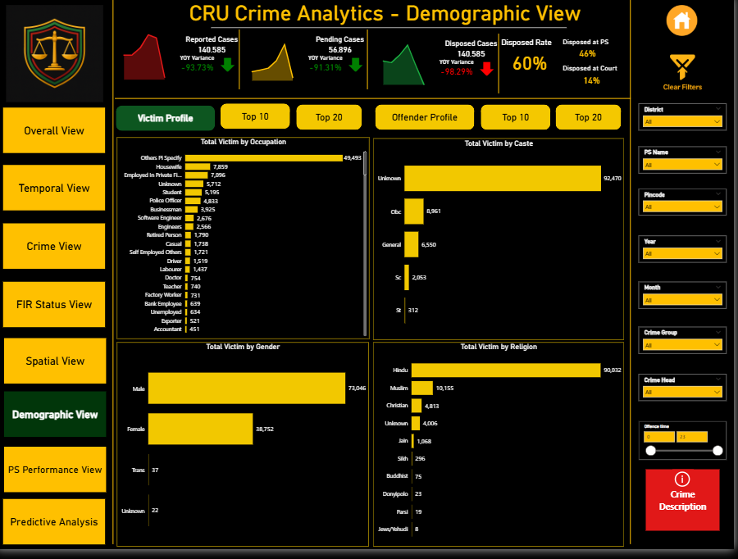
Victim Profile
Aspect | Details
Visual Type | Multiple Clustered Bar Charts (Occupation, Caste, Gender, Religion)
Data Fields Used | Y-axis : [Victim Occupation],[Victim Caste],[Victim Gender],[Victim Religion]  X-axis : [Assign Cases]
DAX Measures Used | [Assign Cases]
Purpose | - To analyze crime victims’ profiles across socio-demographic attributes.  - Identifies vulnerable groups by occupation, caste, gender, and religion.  - Supports resource planning, victim support services, and targeted interventions.
Key Insights | - By Occupation: Highest → Others (PS Ready) (49,493 victims), followed by Housewives (7,859) and Private Employees (7,056).  - By Caste: Majority recorded as Unknown (92,470), followed by OBC (8,961), General (6,550).  - By Gender: Males (73,046) nearly double females (38,752); Transgender (37) cases minimal.  - By Religion: Hindus (90,032) most affected, followed by Muslims (10,155), Christians (4,813).
Problem Areas | - Extremely high Unknown caste (92k+) → data quality gap.  - Gender skew → majority male victims, but female vulnerability (esp. housewives) also significant.  - Occupational category Others (PS Ready) too broad → needs standardization.  - Religion-wise → over-representation of Hindu victims (needs normalization with population share).
Recommendations | - Improve data entry practices → reduce “Unknown” caste/religion fields.  - Disaggregate “Others (PS Ready)” into meaningful categories.  - Special victim support for vulnerable groups (housewives, private employees, students).  - Gender-sensitive policing programs (esp. women safety & awareness).  - Cross-tab analysis of religion × occupation and gender × occupation for deeper insights.

Offender Profile
Aspect | Details
Visual Type | Multiple Clustered Bar Charts (Occupation, Caste, Gender, Religion)
Data Fields Used | Y-axis : [Offender Occupation],[Offender Caste],[Offender Gender],[Offender Religion]  X-axis : [Assign Cases]
DAX Measures Used | [Assign Cases]
Purpose | - To analyze crime offenders’ socio-demographic distribution.  - Helps identify high-risk groups contributing to crimes.  - Supports targeted preventive measures, awareness drives, and rehabilitation programs.
Key Insights | - By Occupation: Majority Unknown (75,591), followed by Others (28,809) and Businessmen (4,173).  - By Caste: Large portion Unknown (109,771), followed by OBC (4,944), SC (2,434), General (1,985).  - By Gender: Males (67,775) dominate → more than 5x females (11,823).  - By Religion: High Unknown (75,007), Hindu offenders (39,705), Muslims (12,528), Christians (3,567).
Problem Areas | - Excessive “Unknown” entries in caste & occupation → limits analysis quality.  - Gender imbalance → indicates crime is male-dominated.  - Occupational grouping “Others” too broad → lacks actionable insights.  - Religion data missing for ~75k offenders (major gap).
Recommendations | - Strengthen data collection standards to reduce “Unknown” values.  - Break down “Others” occupation category into sub-segments (students, unemployed, daily wage, etc.).  - Implement male-focused crime prevention programs and awareness campaigns.  - Cross-tab offender profile with victim demographics → identify patterns like same caste/religion conflicts or occupation-driven crimes.

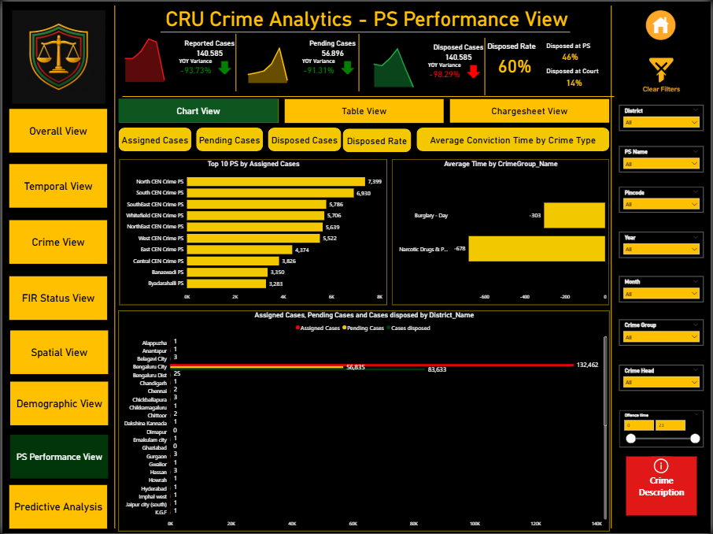

Performance View – Main Sections
Button | Bookmark Triggered | Visuals Shown | Visuals Hidden | Notes
Chart View | PSPerfChart_BM | PS performance charts (Pending, Disposal, etc.) | Table View, Chargesheet View | Default section
Table View | PSPerfTable_BM | Assigned vs Pending vs Disposed (tabular) | Chart View, Chargesheet View | Detailed table comparison
Chargesheet View | Chargesheet_BM | Avg Chargesheet Filing Time chart | Chart View, Table View | Focus on judicial delays

PS Performance – Chart View (Sub-Buttons)
Button | Bookmark Triggered | Visuals Shown | Visuals Hidden | Notes
Assign Cases | AssignCases_BM | Assigned cases per PS (bar chart) | Other Chart View visuals | Shows workload
Pending Cases | PendingCases_BM | Pending cases per PS | Others | Highlights backlog
Disposed Cases | DisposedCases_BM | Disposed cases per PS | Others | Cleared cases
Disposal Rate | DisposalRate_BM | Disposal % per PS | Others | KPI vs benchmark (≥70%)
Average Conviction Time | AvgConviction_BM | Avg conviction time per PS | Others | Delay monitoring

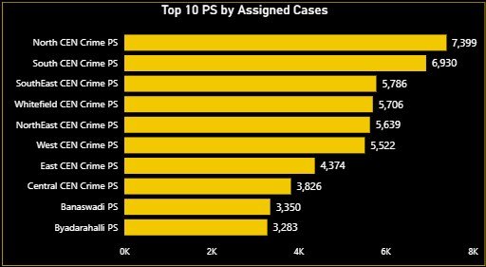

Top 10 PS by Assigned Cases
Aspect | Details
Visual Type | Clustered Bar Chart
Data Fields | X-axis: [Assigned Cases]  Y-axis: UnitName  Filter: Unit Name Top 10 by Assign Cases
Measures Used | [Assigned Cases]
Purpose | To identify which Police Stations (PS) receive the highest number of cases, showing workload distribution.
Insights | - North CEN PS (7,399) and South CEN PS (6,930) have the highest assigned cases.  - Other busy PS include Southeast (5,786), Whitefield (5,706), and Northeast CEN (5,629).  - Smaller PS like Byadarahalli (3,283) have much lower case assignments.
Problems / Limitations | - High assigned cases don’t show efficiency — a PS could have many cases but poor disposal.  - Data does not account for manpower size, so workload fairness is unclear.
Recommendations | - Allocate more manpower/resources to high-load PS.  - Monitor disposal % alongside assignments for true efficiency.  - Review workload distribution across PS to ensure balance.

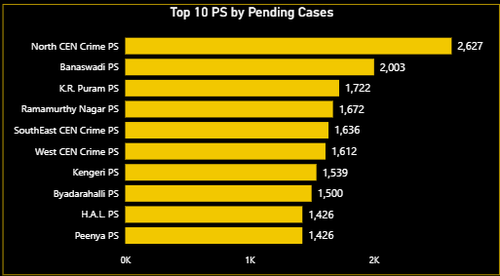

Top 10 PS by Pending Cases
Aspect | Details
Visual Type | Clustered Bar Chart
Data Fields | X-axis: [Pending Cases]  Y-axis: UnitName  Filter: UnitName Top10 by pending Cases
Measures Used | [Pending Cases]
Purpose | To highlight which Police Stations have the most backlog, indicating operational bottlenecks.
Insights | - North CEN PS (2,627) and Banashankari PS (2,003) lead in pendency.  - West CEN (1,612), Byadarahalli (1,563), and Northeast CEN (1,300) also show significant pending loads.  - Smaller PS pendency is lower (<1,200 cases).
Problems / Limitations | - High pendency indicates slow investigation or resource gaps.  - Does not show pendency age (new vs. old cases).
Recommendations | - Prioritize pendency clearance in high-backlog PS.  - Introduce fast-track review for >1000-day pending cases.  - Match case load with available investigators.

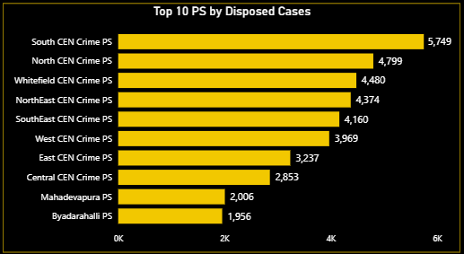

Top 10 PS by Disposed Cases
Aspect | Details
Visual Type | Clustered Bar Chart
Data Fields | X-axis: [Disposed Cases]  Y-axis: UnitName  Filter: UnitName Top10 by Disposal cases
Measures Used | [Disposed Cases]
Purpose | To track which Police Stations are disposing the most cases, showing productivity.

Insights

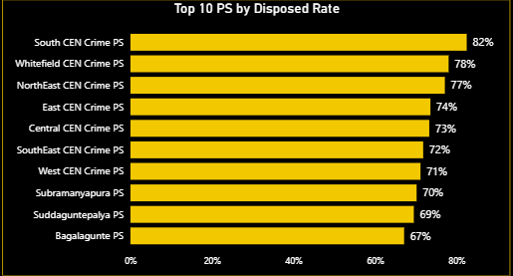

Top 10 PS by Disposed Rate
Aspect | Details
Visual Type | Clustered Bar Chart
Data Fields | X-axis: [Disposed Rate]  Y-axis: UnitName  Filter: UnitName Top10 by Disposal Rate
Measures Used | [Disposed Rate]
Purpose | To measure efficiency of Police Stations in clearing their assigned workload.
Insights | - South CEN PS has the highest disposal rate (82%).  - Whitefield (78%), Northeast CEN (77%), and East CEN (74%) also show strong clearance efficiency.  - Banashankari (44%) and Byadarahalli (56%) are weak performers.

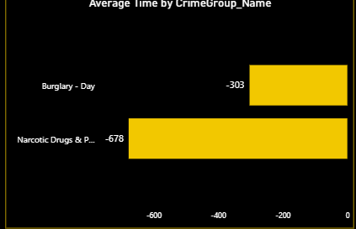

Average Conviction Time by Crime Group
Aspect | Details
Visual Type | Clustered Bar Chart
Data Fields | X-axis: Average Conviction Time  Y-axis: CrimeGroup_Name
Measures Used | [Average Conviction Time]
Purpose | To understand how long different crime groups take to reach conviction.
Insights | - NDPS (Narcotic Drugs) shows the longest average trial duration (-678 days, pending bias).  - Burglary (Day) averages -303 days.  - Indicates slow conviction in serious crime groups.
Problems / Limitations | - Negative values reflect calculation based on pending trials, so interpretation must be cautious.  - Conviction time depends heavily on court process, not just PS work.
Recommendations | - Create dedicated NDPS fast-track courts.  - Prioritize burglary and narcotics trials for quicker resolution.  - Improve coordination between police & judiciary.

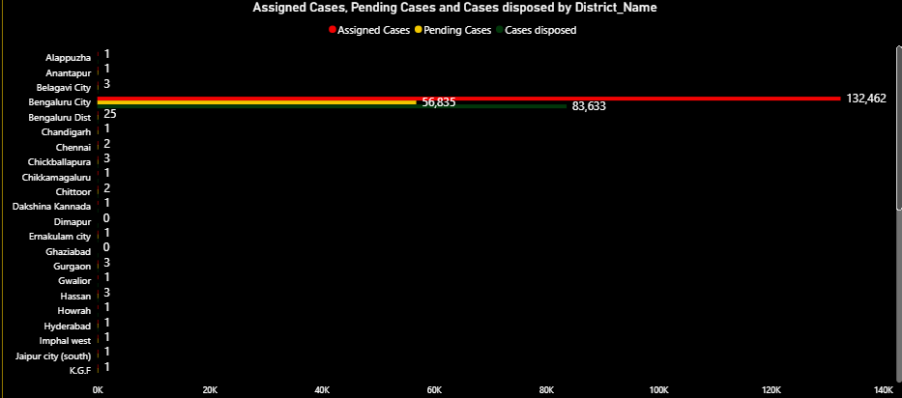

Assigned, Pending & Disposed Cases by District
Aspect | Details
Visual Type | Stacked Bar Chart
Data Fields | X-axis: [Assign Cases],[Pending Cases],[Disposed Cases]  Y-axis: District Name
Measures Used | [Assigned Cases], [Pending Cases], [Disposed Cases]
Purpose | To compare workload and performance across districts.
Insights | - Bengaluru City dominates workload (132,462 assigned, 83,633 disposed, 56,835 pending).  - Smaller districts (e.g., Alappuzha, Gwalior) have minimal case counts.  - Imbalance is clear — urban hubs carry far higher burden.
Problems / Limitations | - District size/population not factored — so absolute numbers may look skewed.  - Does not show disposal efficiency by district.
Recommendations | - Normalize cases by population for fair comparison.  - Provide extra manpower/resources to top-burden districts.  - Regularly track district pendency vs. disposal ratio.

Challenges Faced During Dashboard Development
- Data Quality Issues
  - Observation: Age and gender fields had missing values.
  - Action: Created calculated columns and bucketed age into segments (Child, Youth, Adult, Old).
- Partial Year Data (2025)
  - Observation: Only half-year data available, causing misleading YoY results.
  - Action: Excluded 2025 from YoY logic and marked it clearly as YTD.
- Complex Navigation
  - Observation: Multiple buttons and bookmarks required for toggling visuals, making report management challenging.
  - Action: Organized bookmarks systematically and documented navigation.
- Performance Optimization
  - Observation: Bookmark-heavy visuals slowed report performance.
  - Action: Disabled unnecessary interactions and optimized visual layering.
- Spatial View Data Type Issue
  - Observation: Crime hotspot map did not display all locations. Investigation showed longitude and latitude columns were stored as Whole Number instead of Decimal.
  - Action: In Power Query, modified the transformation step and changed data type to Decimal. After correction, locations displayed correctly.
- Average Conviction Time Issue
  - Observation: Average conviction time calculation returned blanks/zeros. Conviction Date column had missing values and incorrect data type/locale.
  - Action: In Power Query, changed data type to Date and adjusted locale (India). This resolved the issue, and valid conviction times were calculated.

